Harry Crane

Abstract

This project documents the research into different sorting algorithms and their implementations. Using that knowledge, I document the creation of an educational website to visualise and explain the different sorting algorithms. The final product can visualise five separate algorithms, the speed of the visualiser can be adjusted alongside the number of items to sort. As it is visualising, the number of swaps and comparisons made by the algorithm is displayed, allowing the comparison of the different algorithms.

EXTENDED PROJECT

**Creating an educational web application to visualise sorting algorithms**

Table of Contents

Introduction 3

Research Report 4

React.js 4

TypeScript 4

Sorting Algorithms 4

Bubble sort 4

Quick Sort 4

Insertion Sort 4

Merge Sort 5

Selection Sort 5

Development 6

Setup 6

Basic Page setup 8

Adding bars 10

Algorithm select 15

Bubble Sort 17

Select algorithm Fix 17

Visualization 18

Speed 19

Stepping forwards and backwards 20

Colour change 21

Swaps and comparisons 25

Type cleanup 27

Algorithm Description 29

Progress bar 31

Component clean-up 32

Colour scheme 36

Using the colour scheme 37

Implementation of the other algorithms 38

Conclusion and evaluation 47

Bibliography 48

# Introduction

In the context of computer programming, the process of sorting is defined as “marshalling things into ascending or descending order.” (Knuth, 1989). The specified order can come in multiple varieties; however, it is most commonly alphabetical or numerical. Whist this process is helpful when some data might be needed in a sorted format, sorting algorithms are also used as a part of other more complicated algorithms. An example of this would be a binary search, where in order to search for an item, the data must first be sorted. Because of this, sorting algorithms are a crucial part of comput­­­­­­­er programming. Sorting algorithms are also frequently used to explain complicated programming topics.

An example of this is recursion, where a “function is deﬁned in terms of preceding functions or reduces to the successor function” (Watumull, et al., 2014). I have personally experienced this in my computer science and further maths studies. The problem I faced was that the visualisations and explanations of these algorithms were both visually and verbally daunting, resulting in difficulty comprehending them. I aim to fix this difficulty by creating an educational web application to visualise sorting algorithms. I decided to focus on creating a web application due to the increased compatibility it provides. Web applications were also of particular interest to me as they were a programming field I had yet to branch into. I will create this algorithm using the react JavaScript framework with TypeScript.

# Research Report

## React.js

React.js is a JavaScript library for building user interfaces created by software engineers at Facebook in 2011 as a way of optimising and streamlining their development process (RisingStack Engineering, 2021). Since that early inception, it has grown to be the most popular web framework as according to the 2021 Stack overflow developer survey (Stack Overflow, 2021). The major appeal of React, is that it is component based, which means that you can “Build encapsulated components that manage their own state, then compose them to make complex UIs” (Meta Platforms, Inc, 2022). This will help me in the creation of my application as it will allow me to break it down into modular, reusable components, reducing the occurrences of repeated code.

## TypeScript

TypeScript is a statically typed programming language built on top of JavaScript developed and maintained by Microsoft. It was rated the Third most loved programming language in the 2021 Stack Overflow developer survey (Stack Overflow, 2021). The benefit of typescript is that it provides much greater debugging capabilities. It contains the versatility of JavaScript combined with the added benefits of compiled, statically typed languages like Java or C++. (Microsoft, 2022)

## Sorting Algorithms

### Bubble sort

Bubble sort is one of the simplest algorithms to understand and implement. It works by repeatedly iterating through an array and continuously swapping adjacent elements if they are in the wrong order (Geeks for Geeks, 2022). If you were sorting in ascending order, the algorithm would step through an array and at every step, it checks if the current element is larger than the next element. If it is, those elements are swapped. Once the algorithm reaches the end of an array, it repeats the process, starting from the beginning. This results in the largest elements 'bubbling' up the array. Each iteration of the array is known as a run. You know the array is sorted once no elements are swapped in a run. This is because every element is less than the element that follows it. Although some claim that “bubble sort seems to have nothing to recommend it” (Knuth, 1989), bubble sort is a great introduction to both algorithms and sorting. This is because it contains some very simple rules that are repeated.

### Quick Sort

Quicksort is one of the fastest algorithms once implemented. It was created by the British computer scientist Sir Antony Hoare in 1962 (Hoare, 1962). Quicksort works by taking a pivot, then moving all the elements greater it to the left or right. depending on whether you are sorting in increasing or decreasing order, respectively. This then creates two subsections, one where all elements are greater than the pivot and one where they are less than. This process is then applied recursively to each subsection, with each time splitting a sublist into two more sub lists until the list is sorted. You know it is sorted once each subsection is one long.

### Insertion Sort

Insertion sort works by splitting a list into two sections, sorted and unsorted. The first element is automatically classed as sorted. The element directly next to the sorted section is then swapped backwards until it is in order in the sorted area. This means that it is continuously swapped with the element to its left until that element is greater or less than depending on whether you are sorting in ascending or descending order. The list is sorted once the unsorted section has no elements yet. (Kahn Academy, n.d.)

### Merge Sort

Merge sort works by continuously splitting a list in half until the subsections are of length one. Once a list has been fully broken down, the sections are merged back together in the reverse order. With each merge, the sections are sorted. This means that since both sections are sorted, it is simple to sort them whilst merging by taking the smallest or largest, depending on whether you are sorting in ascending or descending order from both sections until both sections are empty. You know the list is sorted once you have merged back up to the whole list. (Bond, 2017)

### Selection Sort

Selection sort works by splitting the list into two sections, sorted and unsorted. The sorted section starts empty, then depending on is you are sorting ascending or descending, the smallest or largest element is selected from the unsorted section and moved to the end of sorted. This process is then repeated until the unsorted section is empty and the list is sorted. (Geeks for Geeks, 2022)

# Development

### Setup

To start off with, I create a typescript react app with the command `npx create-react-app artefact --template typescript`. This creates a folder called artefact containing all starting code for the project. This folder contains some boilerplate code, most of which will be removed. running the command `npm start` starts the boilerplate app, which looks like this:



The artefact folder looks like this:

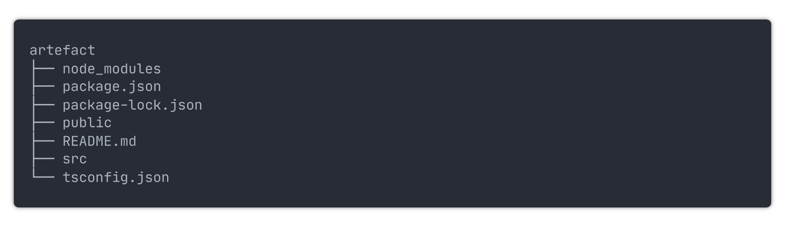

`node_modules` contains the required modules for the project. `Public` contains the `index.html` document where the react app will be injected. And `src` is where the typescript files for the app will go.

I start off by removing all the boilerplate code from the src directory. This leaves me with four files,

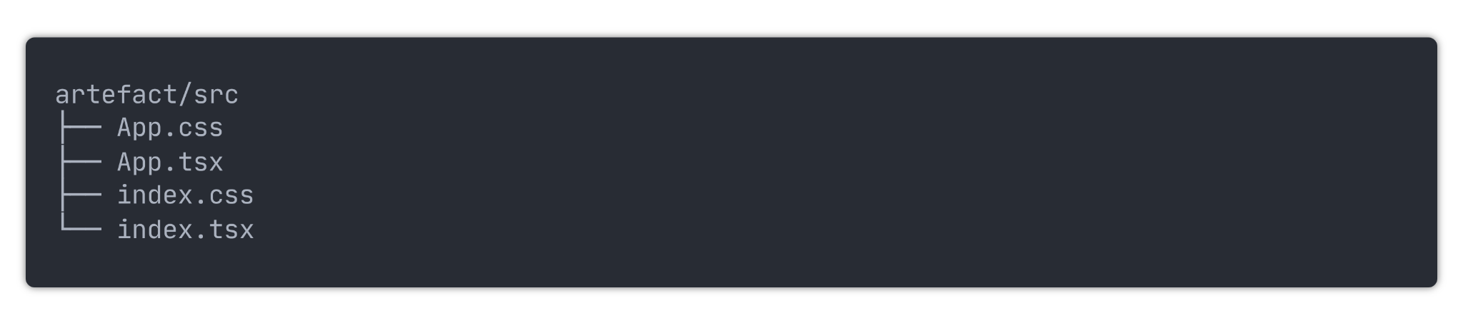

`App.css` is empty and will be where all the component's CSS will go

`App.tsx` is the typescript file where the react components will go. Currently, it contains:

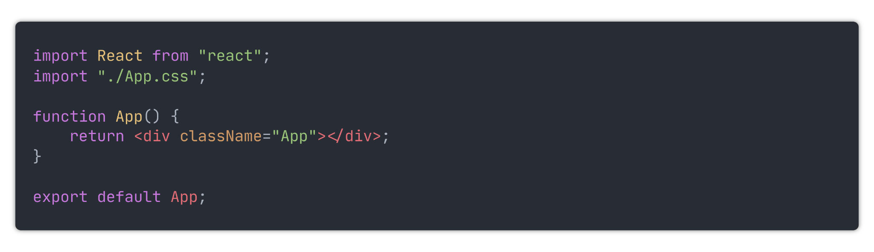

This code returns an empty div element to be injected into the app.

`index.css` contains some extra CSS for index.html, currently it just contains some font styling:

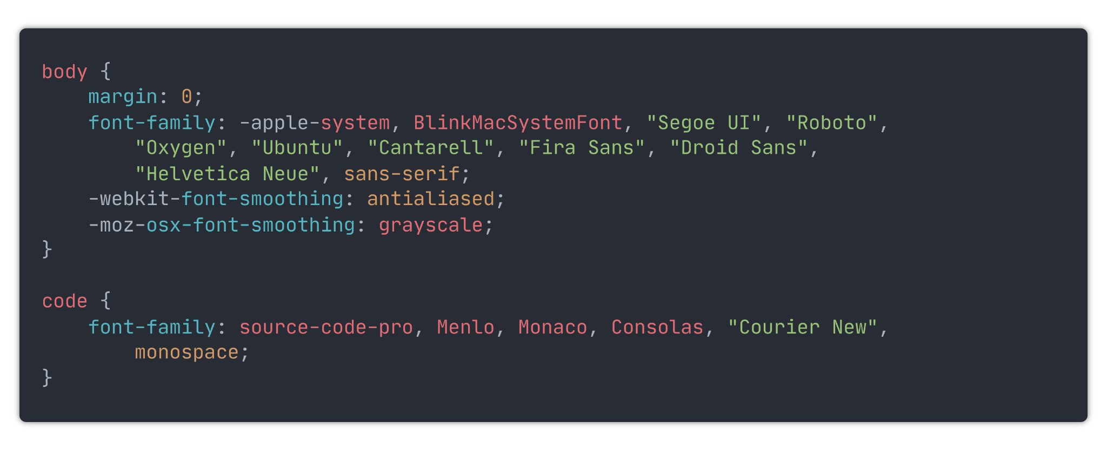

`index.tsx` contains code that injects the empty app element created in `App.tsx`:

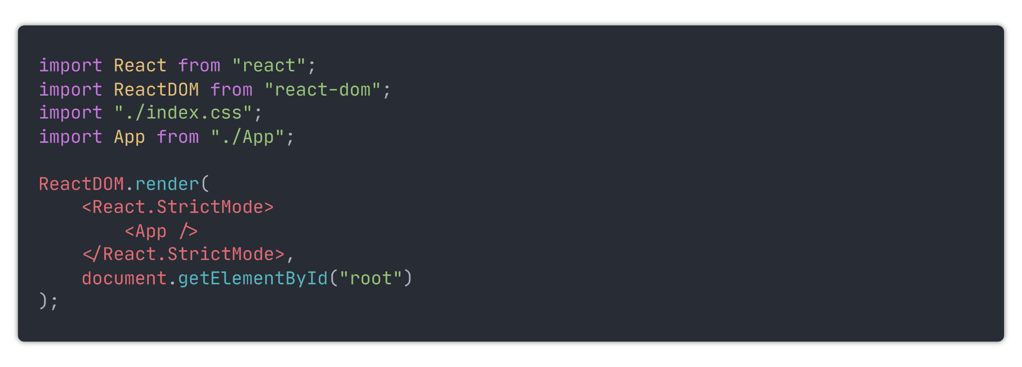

### Basic Page setup

The sorting algorithm page will contain these elements:

- The algorithm visualizer

- A select element to select the selected algorithm

- Buttons to start, stop and reset the visualizer

- Scrolling slide bars to select the number of bars to be sorted, and the sorting speed

- A panel containing metrics on the algorithm, which will display the time taken, number of comparisons and number of swaps

- A place to describe the selected algorithm

So to start off with, I need to create these components inside `App.tsx`. I have not decided on a final visual design for the application, so I will not style the components any more than required to get them working. Then, once I have decided on how the application will look, I will add the CSS to style the components. The file `App.css` now looks like this:

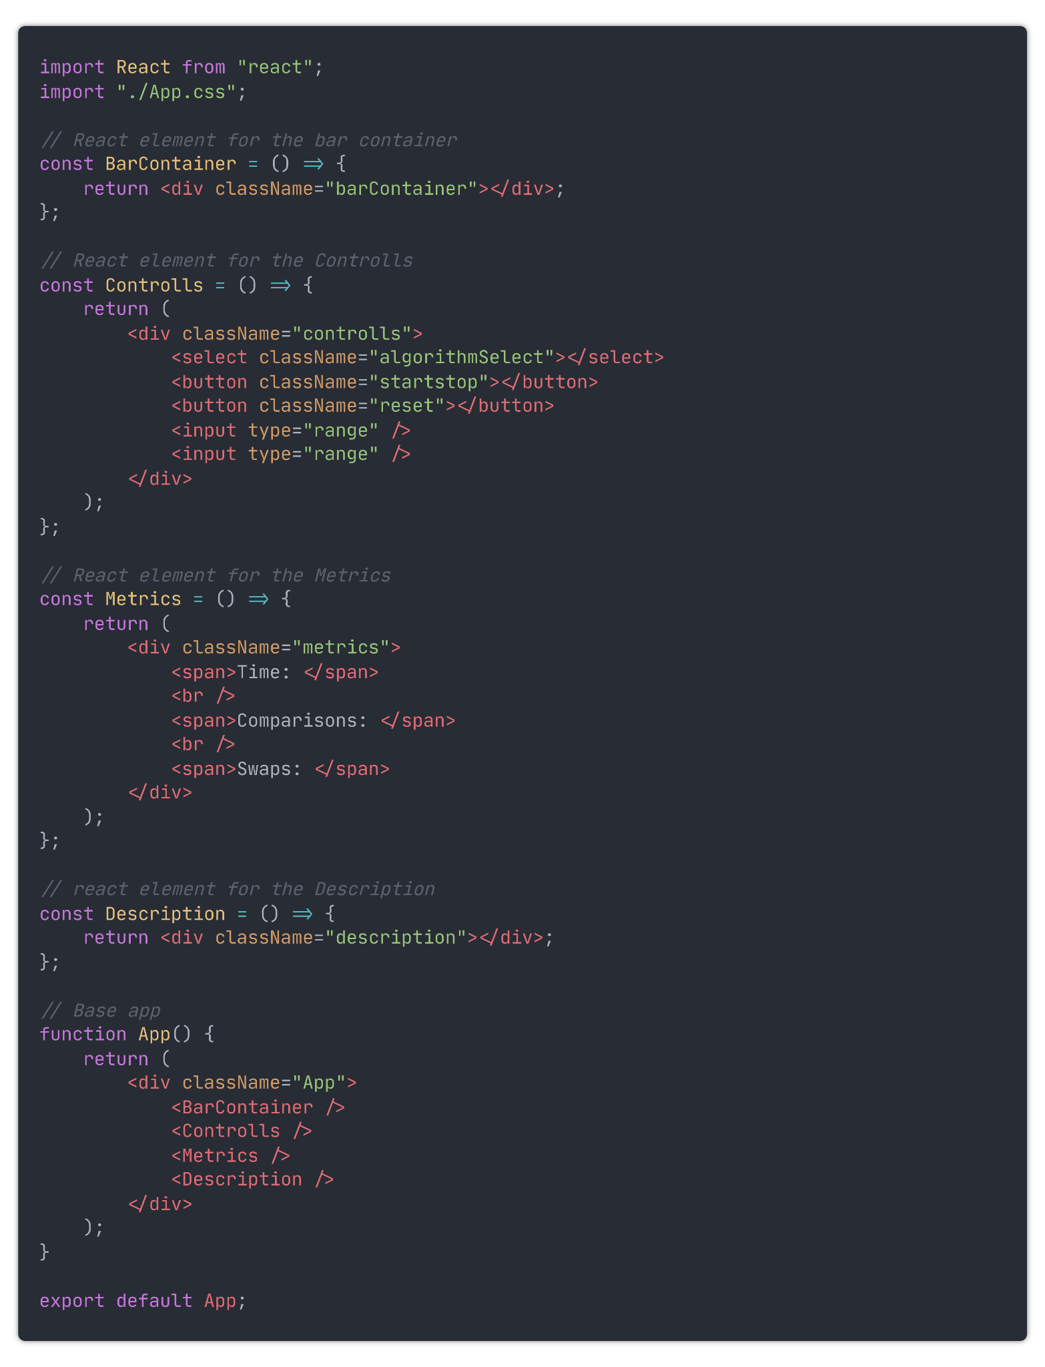

'App.tsx` now contains empty components for the elements of the page. I decided to put the speed, swaps, and comparisons in their own components to make things easier later when I have to update them with their values dynamically.

Now when I run the app it looks like this:

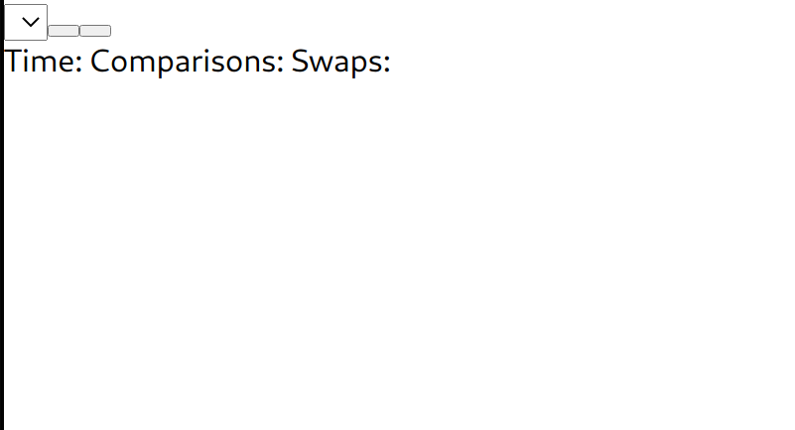

Because there's no styling at all, it is very hard to tell what is going on. Therefore I added some basic CSS styling for the bar container inside `App.css`:

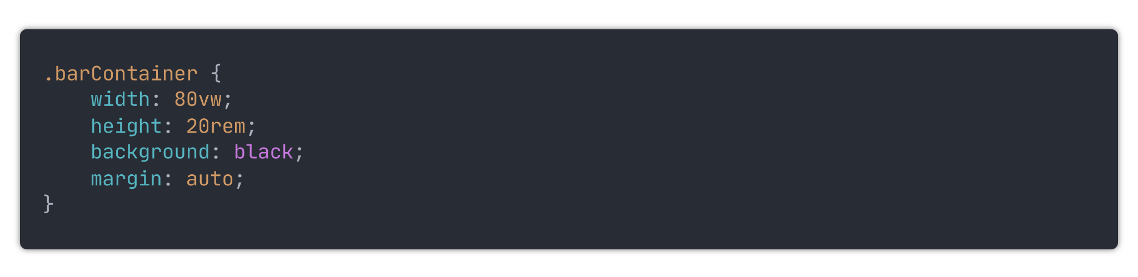

This, plus some added text inside the controls, makes the app now look like this:

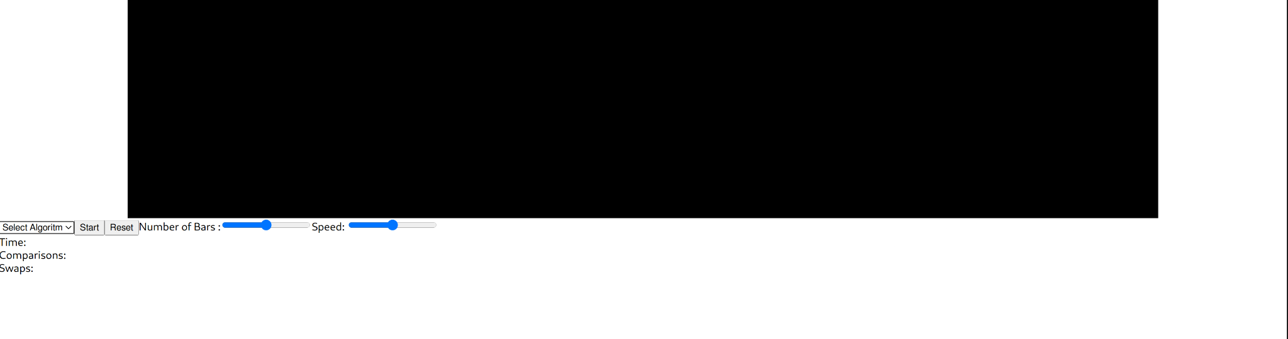

### Adding bars

Now to add some bars, I started by by creating an interface and functional component for the bar:

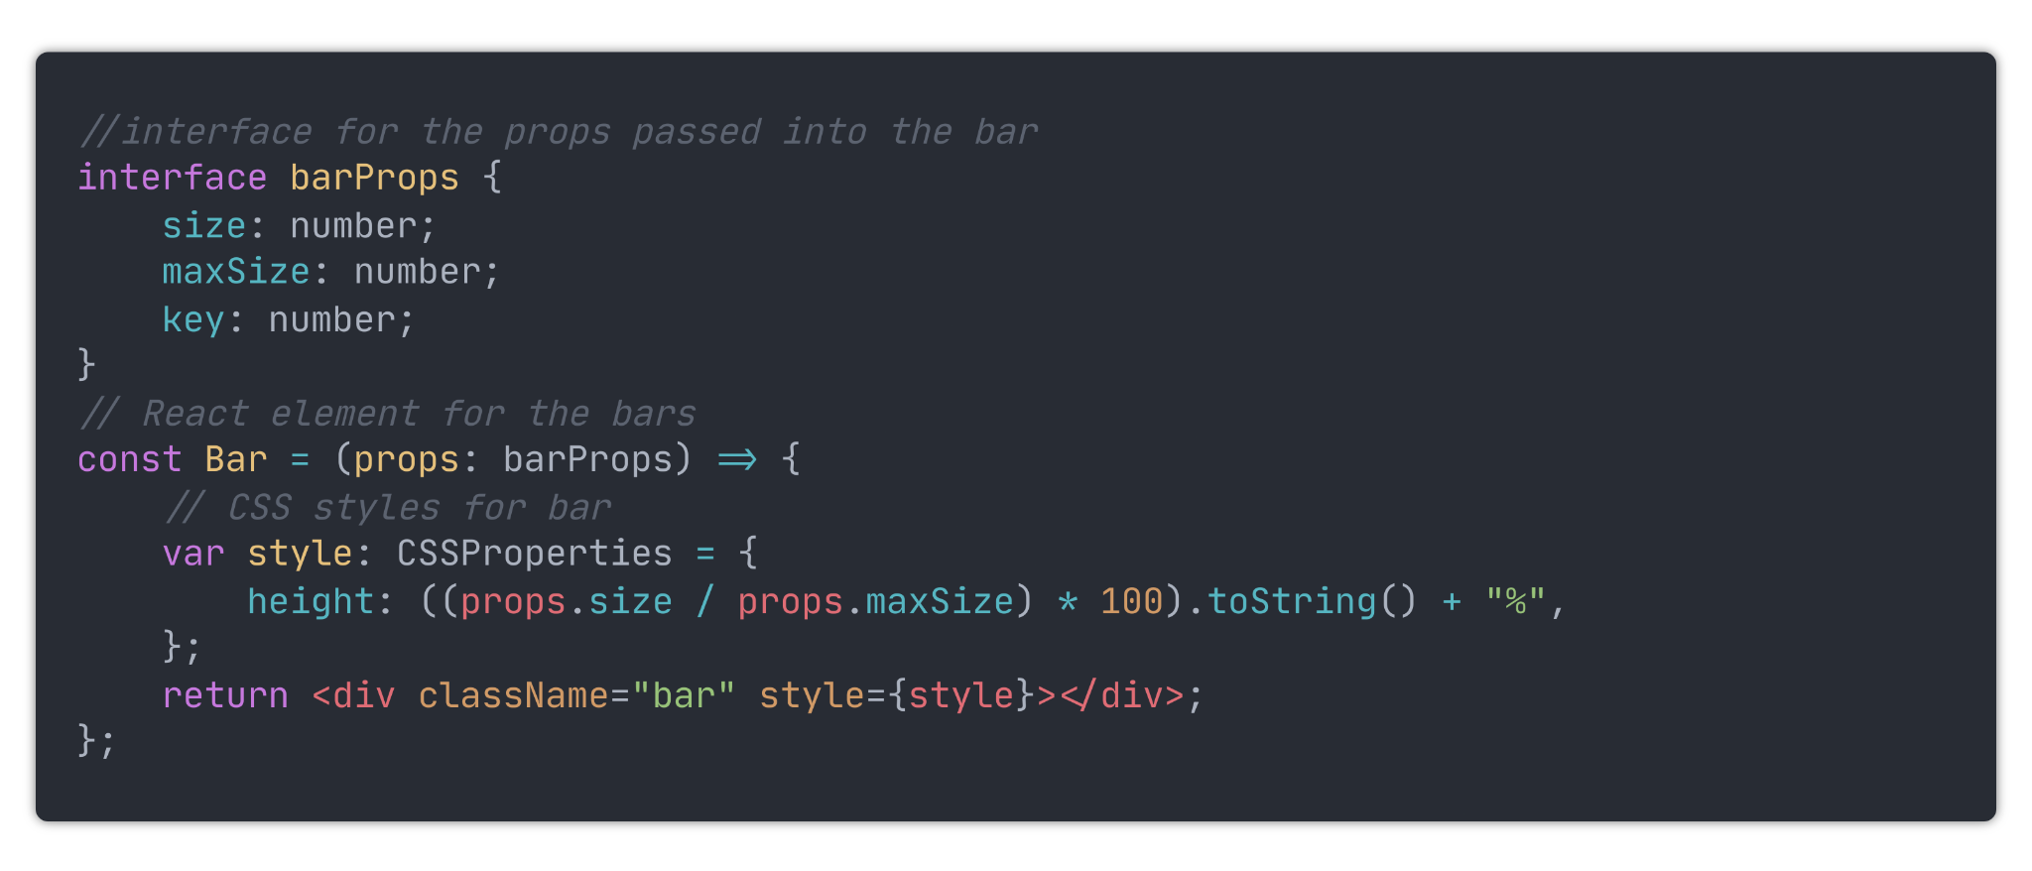

The interface declares the type of props being passed into the bar. These props are then used to determine the height of the bar. The height of a bar is represented as (Bar Size/Max Bar Size) x 100% of the bar container's height.

To create the bars, I first needed a way of creating and storing the size of each bar. I achieved this by creating a `bars` array inside the program state. This array will contain the size of each bar. I also added a variable, `numOBars`, which contains the number of bars to be visualised.

I then created a method that adds the numbers 1 -> numOBars to the bars array. This method is then run when the page loads to create the bars.

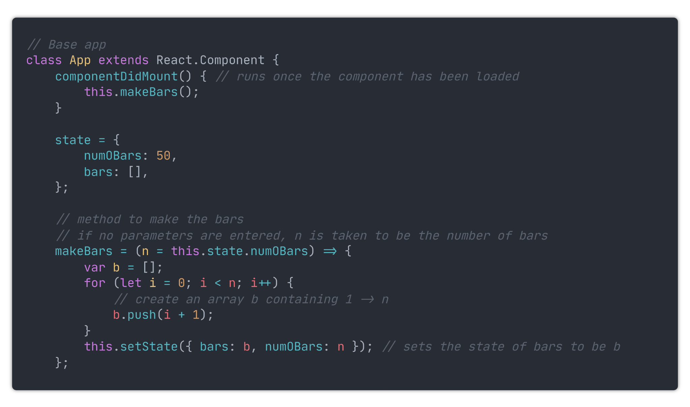

These state values are then passed into the barContainer component, where they are used to create the bars.

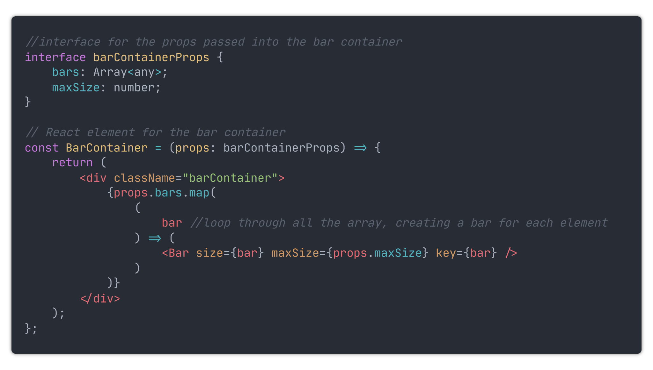

To make the bars centred and visible, I added this CSS styling

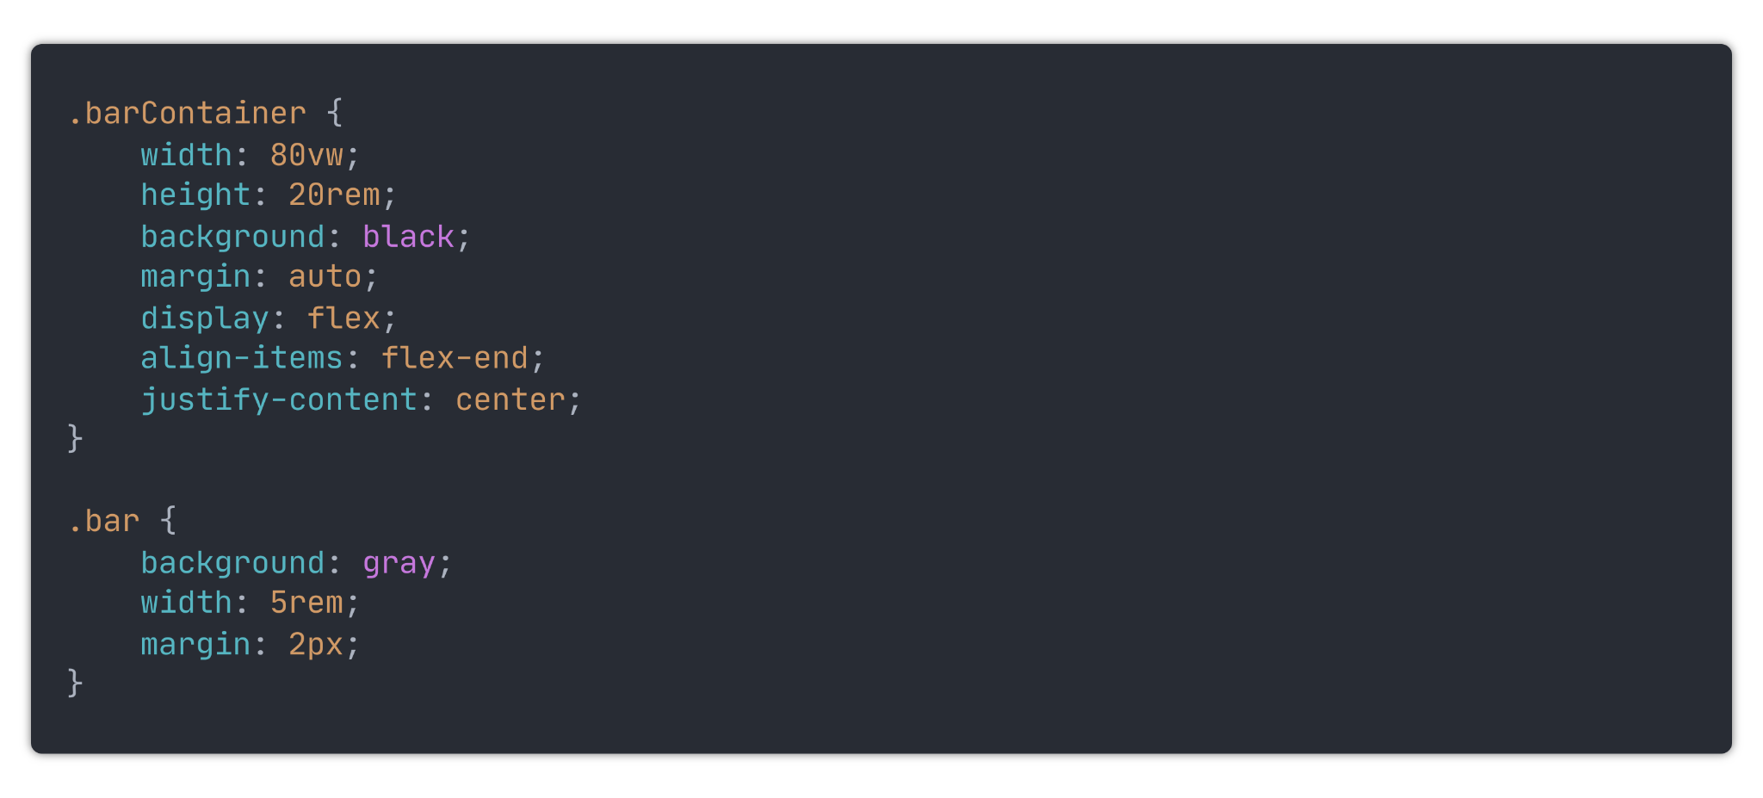

I'm using a CSS flexbox for the bar container for two reasons. Firstly It will allow me centrally align the bars. Secondly, it will compress the elements inside of it so that they all fit. This means that all the bars will dynamically adjust their widths based on how much space is available.

The app with the bars now looks like this:

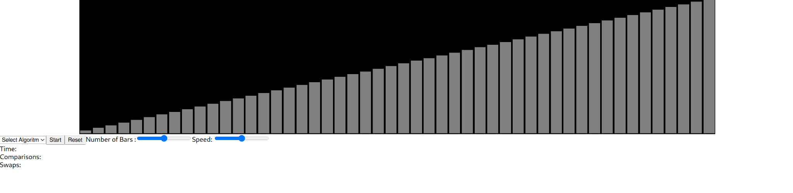

The next thing to do was to allow the number of bars to be edited by the range input created earlier. I moved the code for the `Controls` component into its own file named 'controls.tsx`. This created the codebase easier to deal with as the code is spread over multiple files.

Inside that file I added this code:

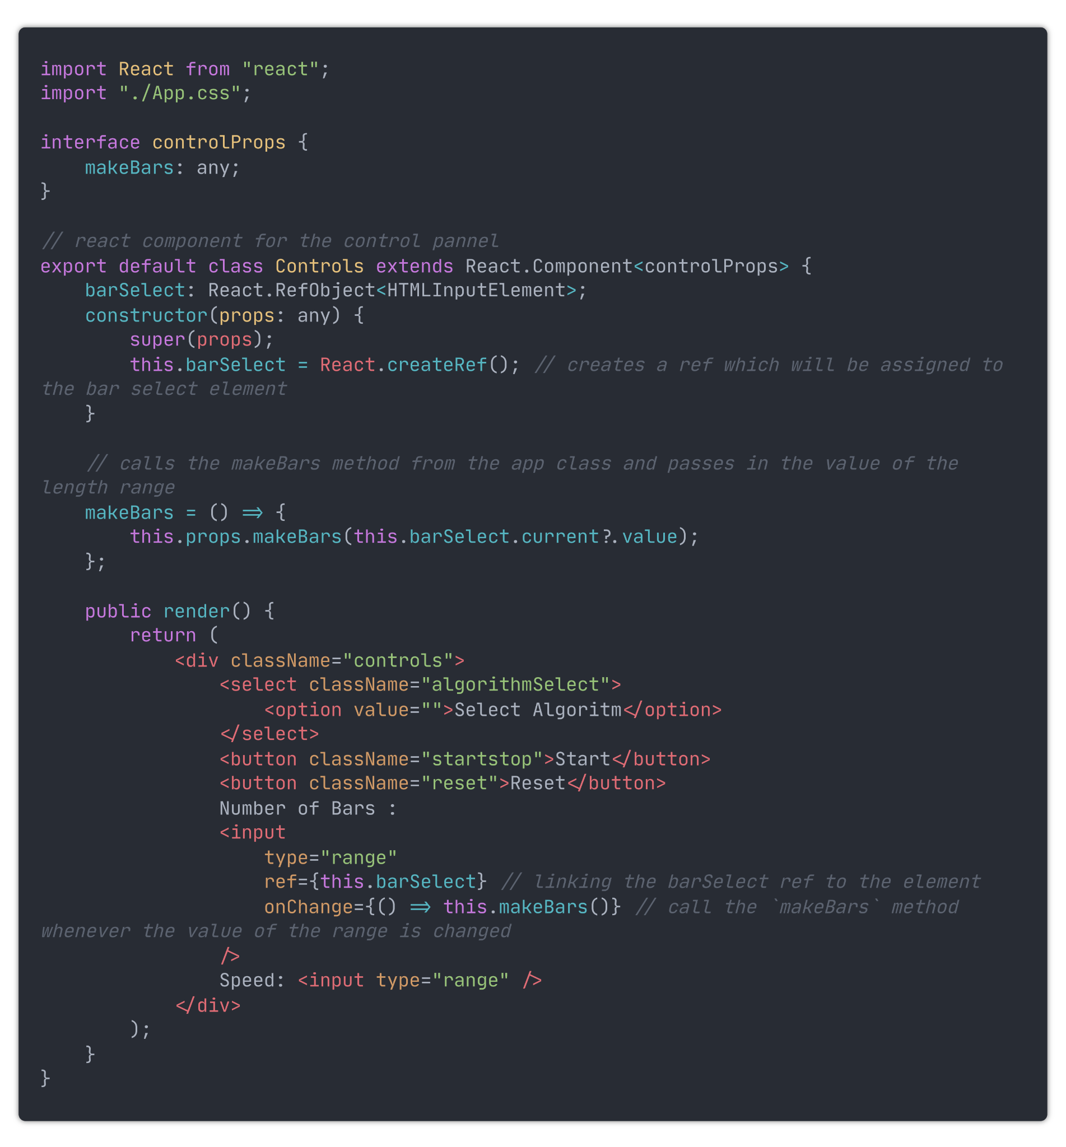

Whenever the value of the range representing the number of bars changes, the method `MakeBars` is called, and the bars are remade.

At the moment, the bars are always created in order, which makes sorting them pretty boring as they are already in order. Therefore inside the `MakeBars` method, I added some code to shuffle the array.

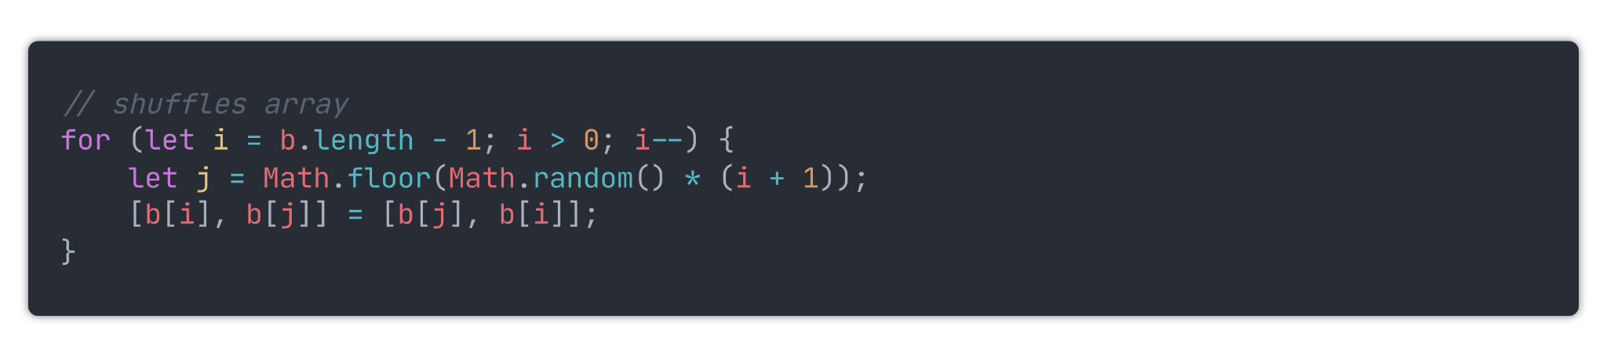

Now, the bars look like this:

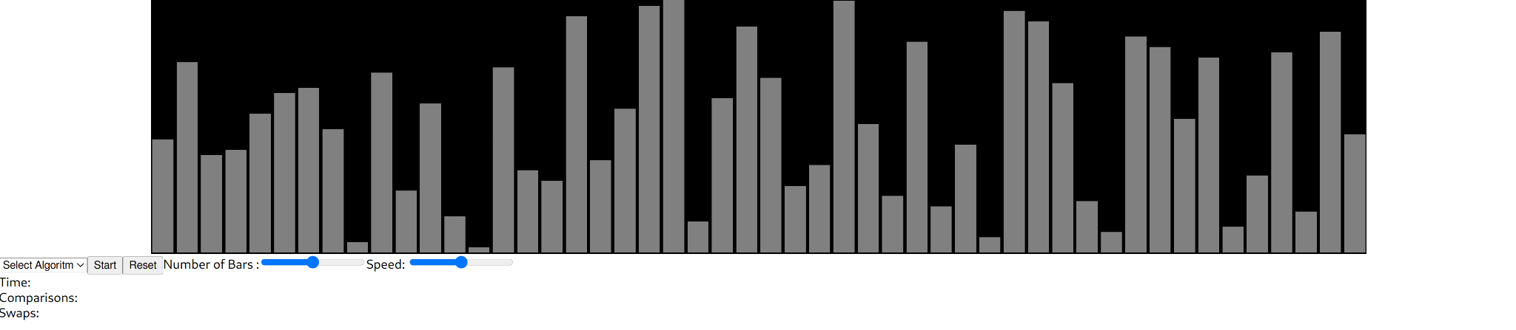

And the range slider can be adjusted to increase or decrease the number of bars, which can be seen here:

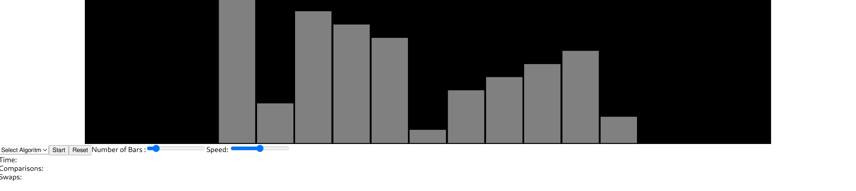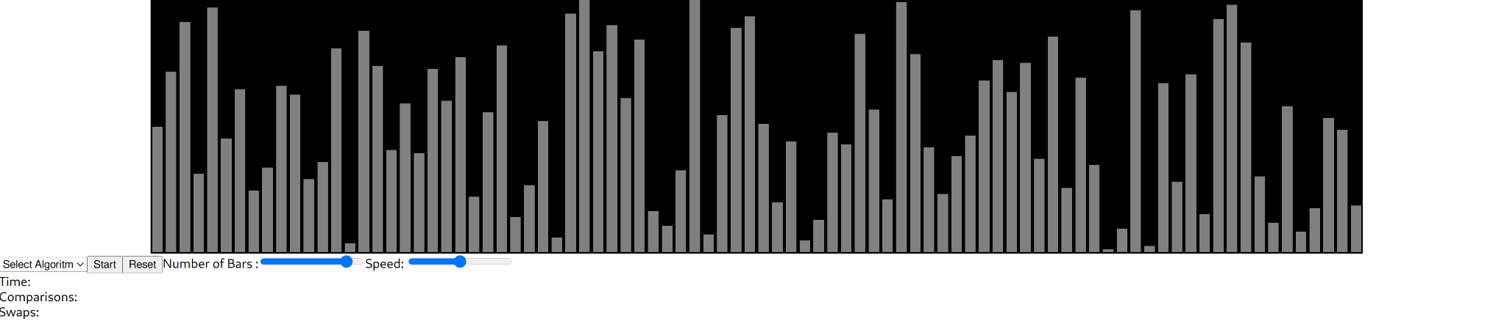

### Algorithm select

The way this application works will be whenever an algorithm is selected, it is run with the state of the bars being appended to the end of an array for every step. Then to display the visualisation of the algorithm, that array is iterated through, with each iteration being set as the bars' current state. I am doing it this way rather than sorting them live (changing the program state as the sorting algorithm is running) because it will allow the user to pause and then resume the visualisation with ease. It will also enable the ability to step forwards and backwards through visualisation.

To start off with, I added three things to the application state, an array containing all the algorithms available to be visualised, an array for the sorting stages, and the stage at which the visualisation is on.

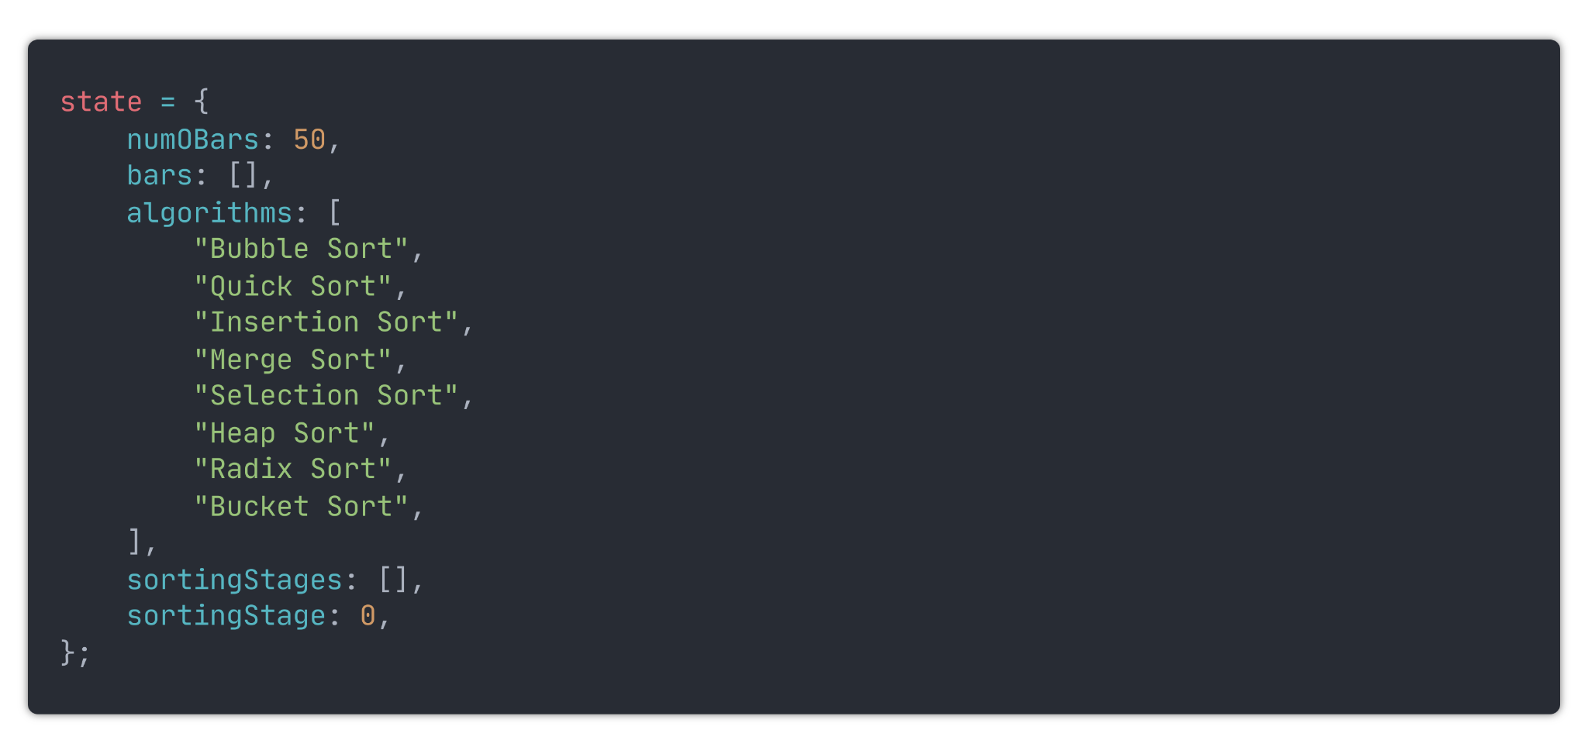

Next, inside the Controls component, I modified the element which selects the algorithm to be used:

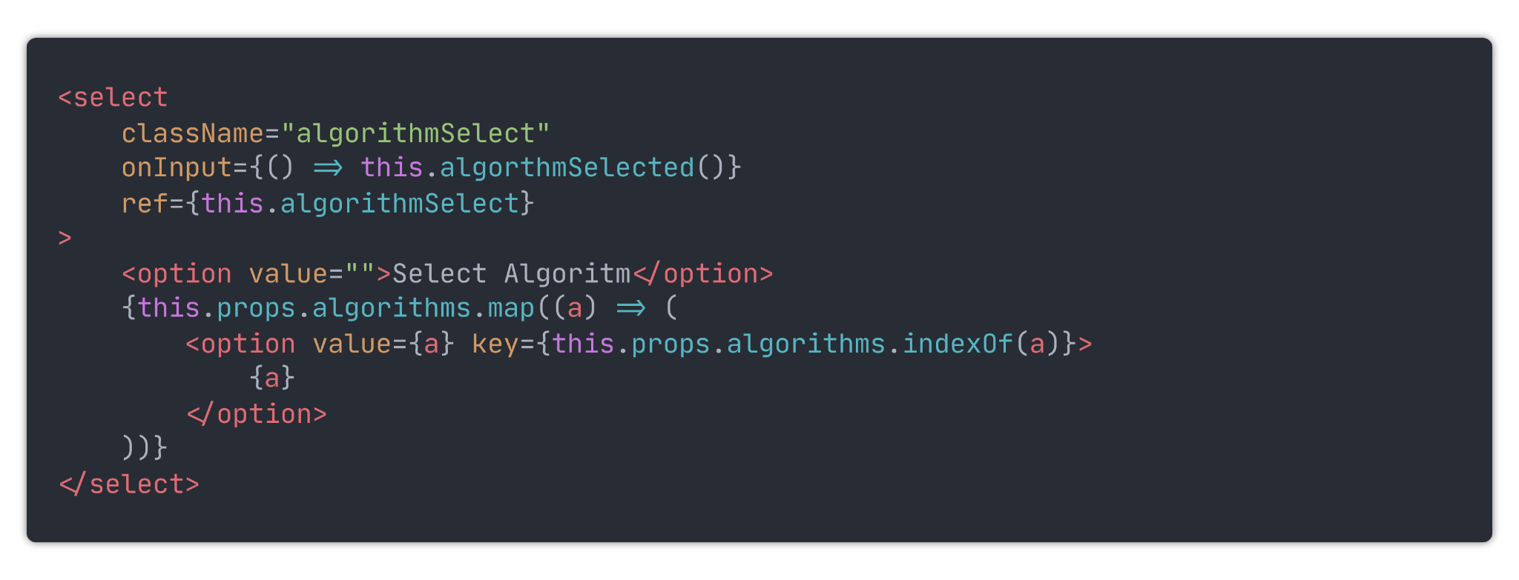

Now it displays an option for all the algorithms. Next, I created a new file named `algorithms.ts` which is where I will put all the functions for the algorithms. These functions will take in the bars array and return an array containing all the steps involved in sorting the bars. Then, inside the App class, I created a method to run the sorting functions. This method will be passed into the Controls class and run whenever an algorithm is selected. At the moment, it only calls for the bubble sort for testing purposes. Once the code works, I can add in the other algorithms.

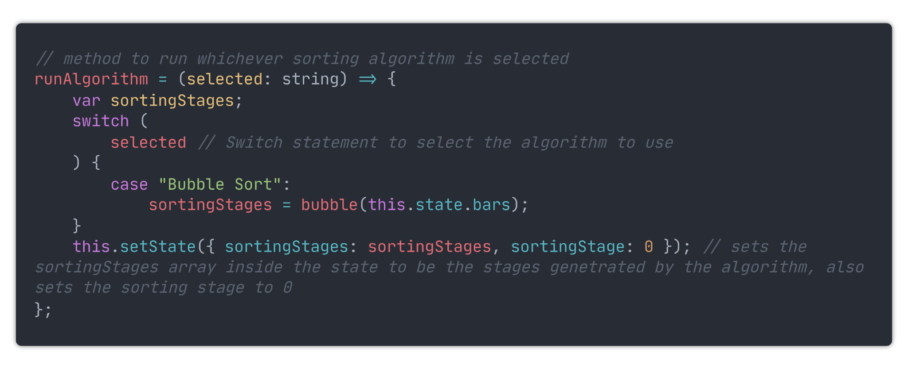

### Bubble Sort

I will only implement the bubble sort whilst I am creating the user interface, once that is complete. I will implement the other algorithms. Here is my implementation of bubble sort:

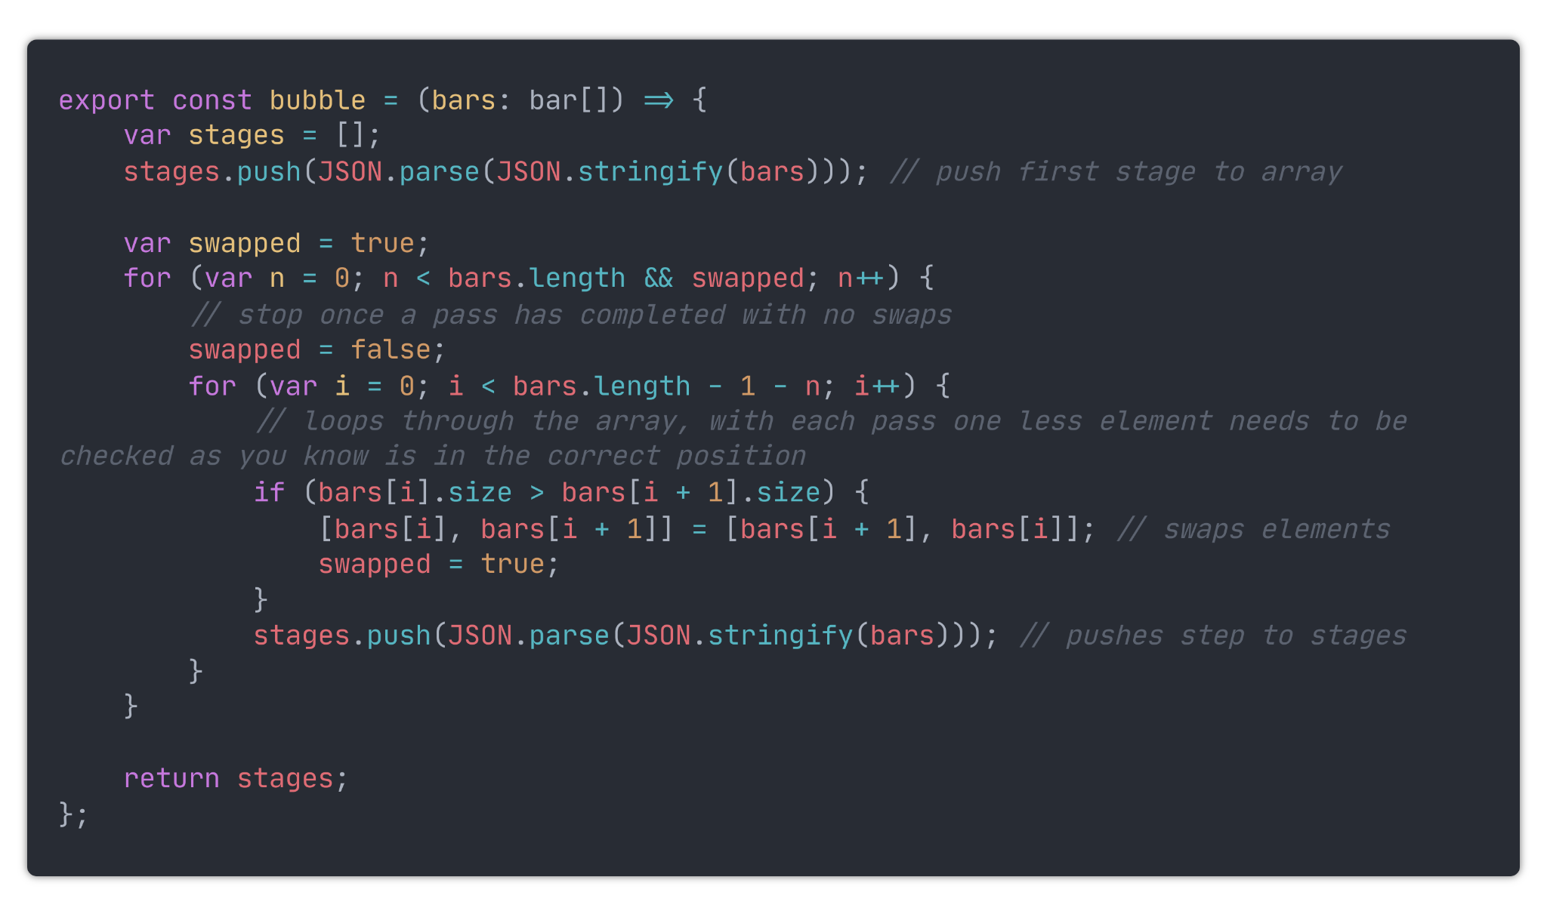

### Select algorithm Fix

Now, whenever bubble sort is selected, all the steps for bubble sort are computed and saved. An issue at the moment, though, is that if you change the number of bars or reset them, the steps are not updated. One way I could fix this is to call the algorithmSelected function every time the bars are redrawn; however, this would be very computationally heavy, so a better way to do it is this. Store a new variable named `selectedAlgoritm` inside the application state. Then add a new method inside the App class, which sets this value. That method will then be called instead of `runAlgorithm` whenever a new algorithm is selected. `runAlgorithm `will then only run when the user presses play for the first time.

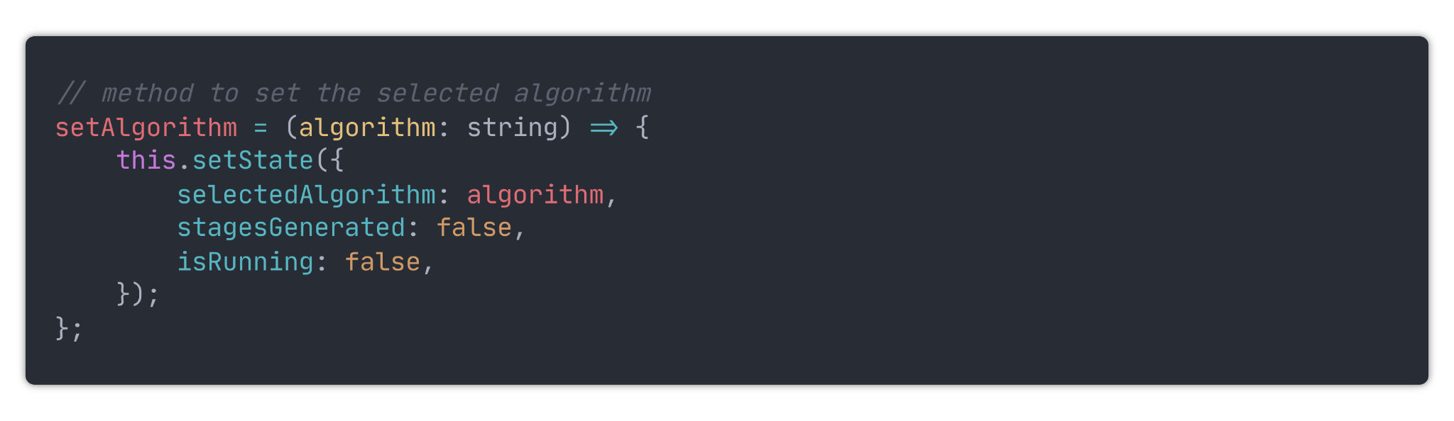

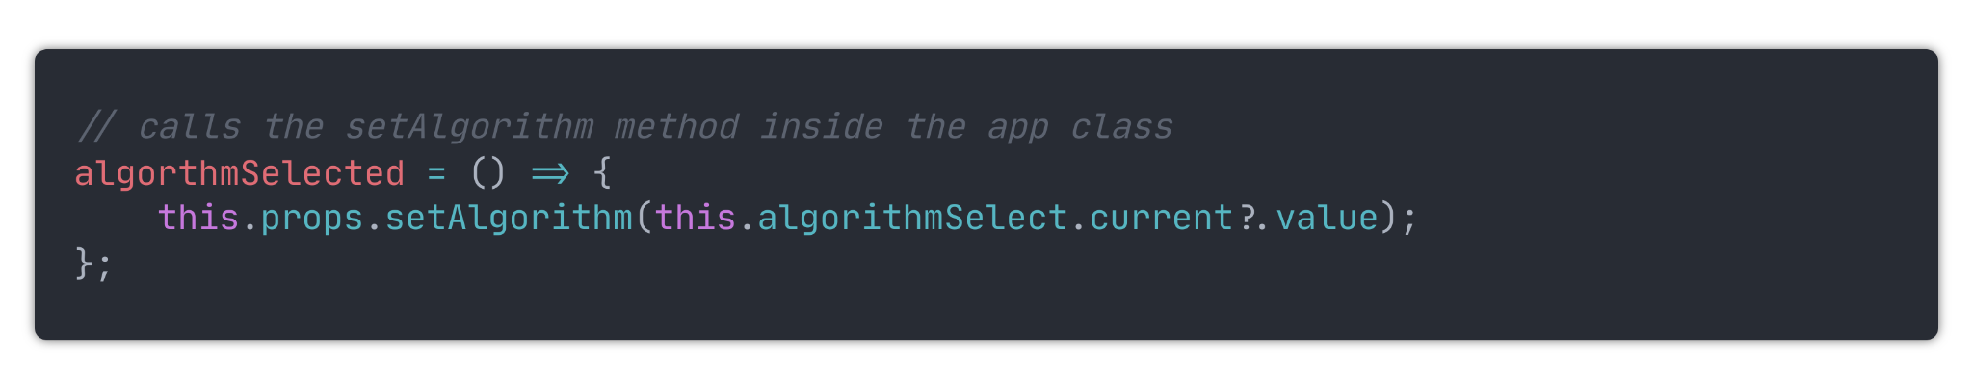

### Visualization

named `isRunning`, which will indicate when the visualiser is running. I then passed that variable to the `Controls` class, where it is used to set what is said on the playPause button.

That button then calls a method inside the App class called `togglePlayState` onClick.

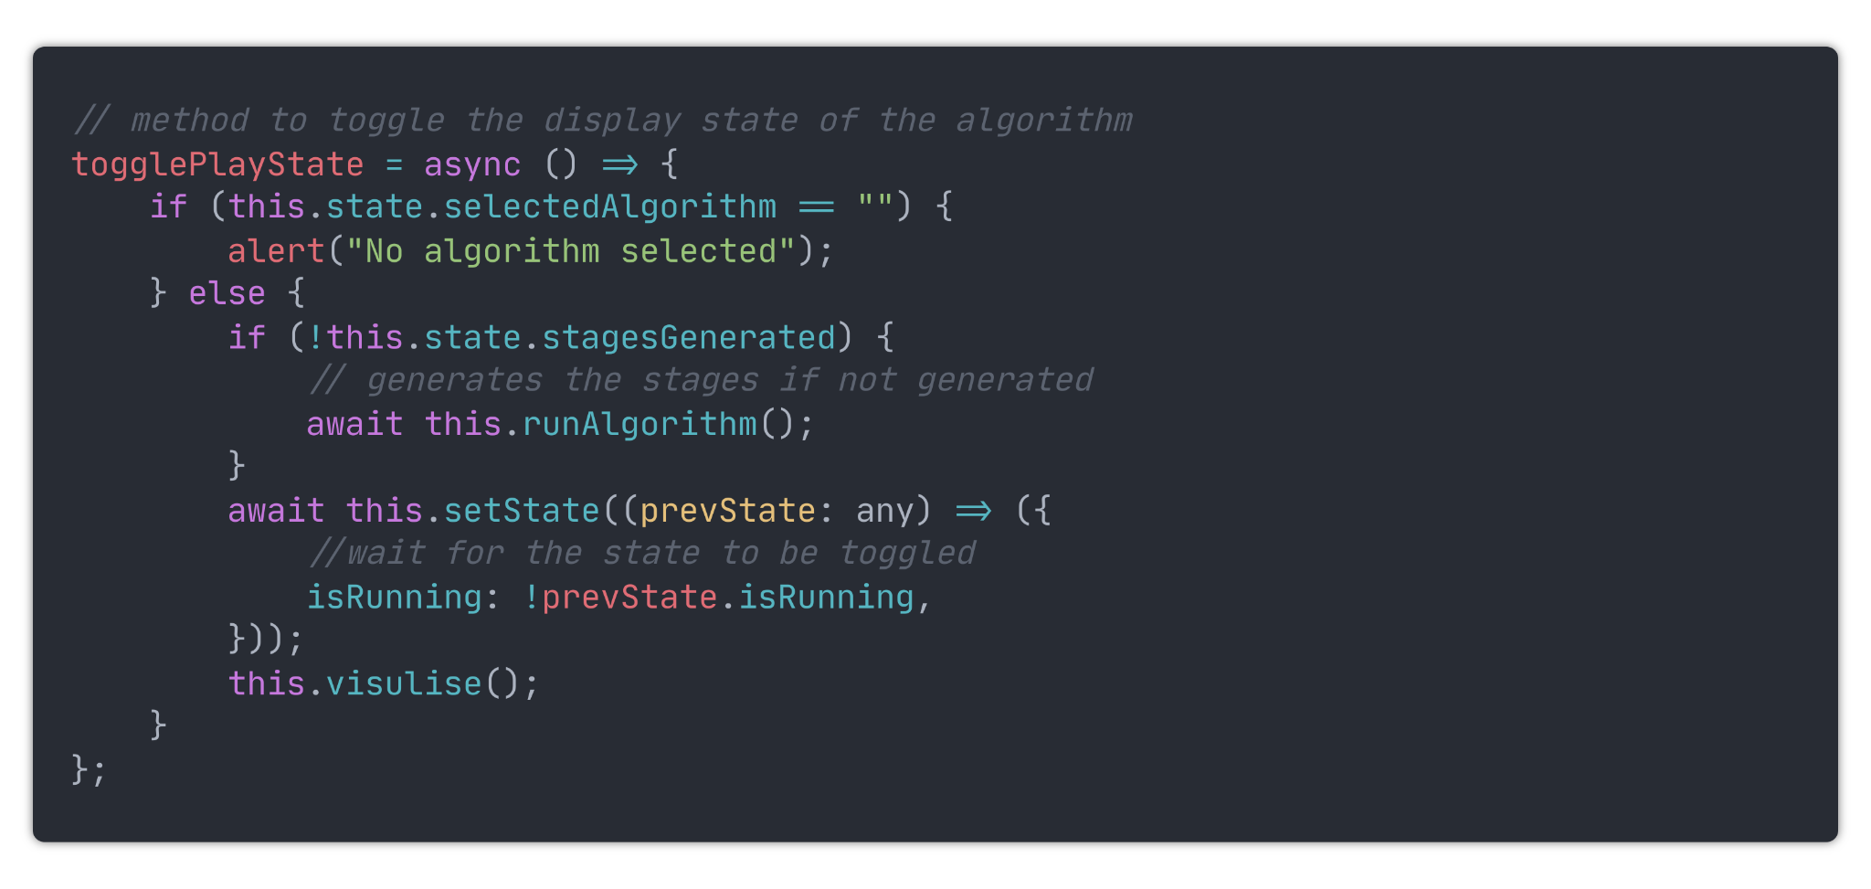

Firstly this method checks if an algorithm has been selected. If not, an alert is displayed. Then, it generates the sorting stages if they have not already been generated. Following that, it then toggles the `isRunning` variable inside the application state. I have set it to await this function because otherwise, it runs asynchronously, which will result in the variable not being toggled when the visualisation starts, causing it not to start.

I then run the visualisation method, which will visualise The selected algorithm.

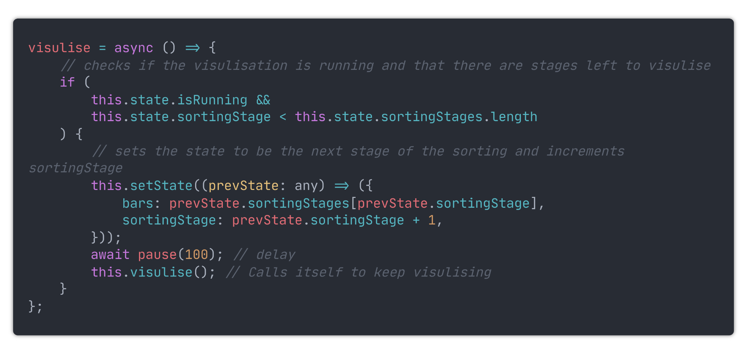

This method is recursive, which means it calls itself. It will continue to call itself until either `this.isRunning` is set to false or all the sorting stages have been visualised.

### Speed

Now, when bubble sort is selected, and the start button is pressed, bubble sort will start or resume being visualised. Likewise, the visualisation is paused when the stop button is pressed. At the moment, the algorithm has a fixed delay of 100ms hardcoded into the visualise method. Now I need to make it so that the speed range slider affects the delay of the visualisation.

I did this similarly to how the bars are set. Whenever the range slider for the speed is changed, a function is called to set the `speed` variable in the program state to 1000 - range value. that is then used in the place of the hardcoded 100ms.

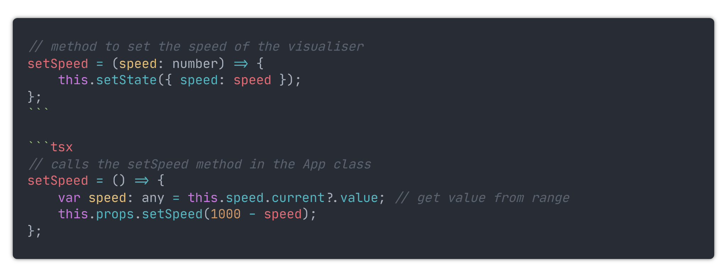

Now, the speed slider can change the speed at which the visualiser is displayed.

### Stepping forwards and backwards

I added two new buttons to the Controls component, these will allow you to step forwards and backwards through the visualization.

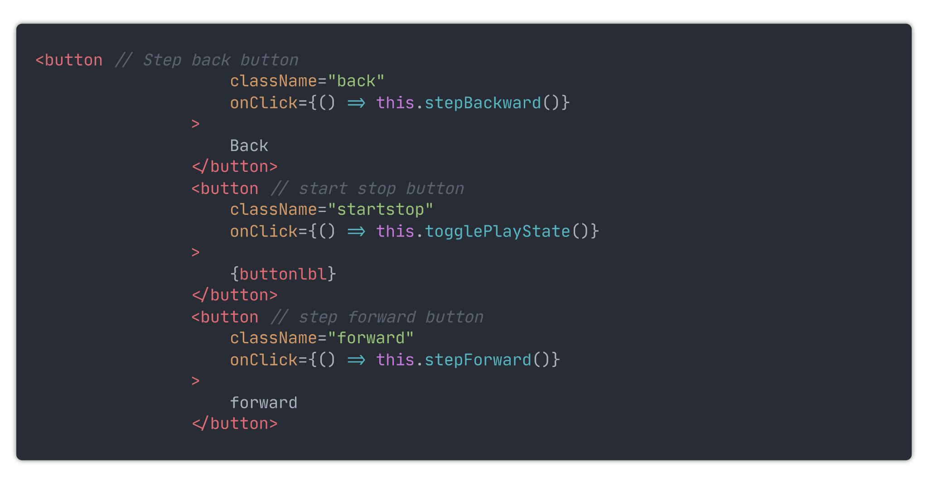

They then call these methods in the app Component when clicked.

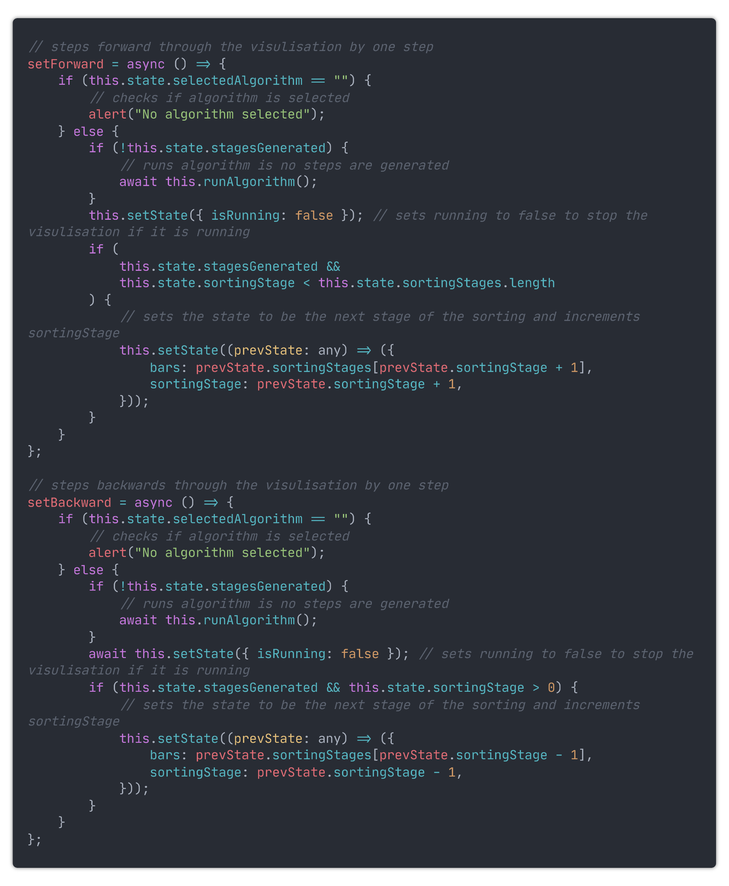

### Colour change

Although the algorithms can now be visualised, it is hard to follow as you can only see change when swaps occur. To rectify this, I will add different colouring to the bars depending on their current state. I have not decided on the final look of the application is, so I will use temporary colours.

The different states a bar could be are :

- Unsorted

- Sorted

- Selected

- Pivot

To start with, I moved all the code for the bars into a new file named `bar.tsx`. I then added a new field into the `barProps` interface called state, which will store the state of the bar.

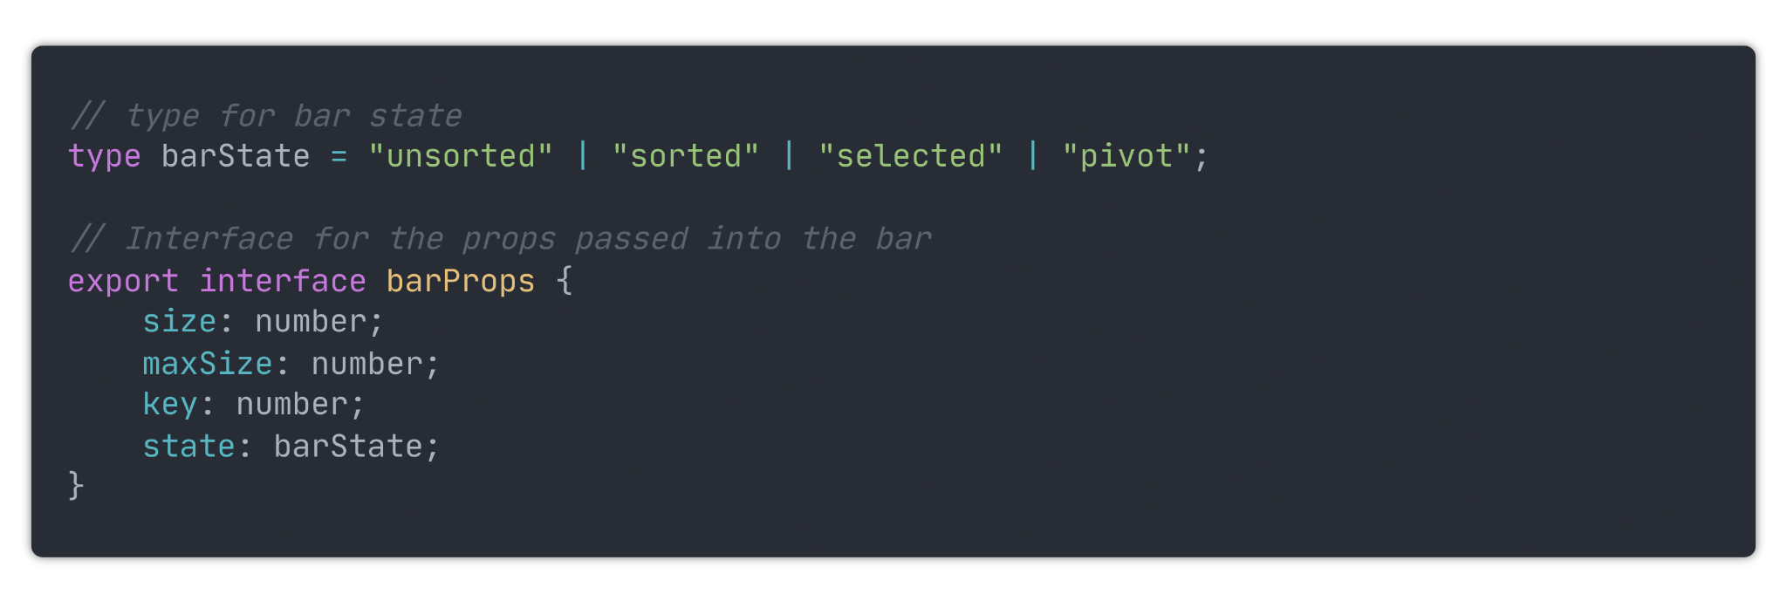

I created a custom type for the bar state, meaning the bar state can only be set to one of the four types. I then added a switch statement into the bar component to assign the colour based on the state of the bar.

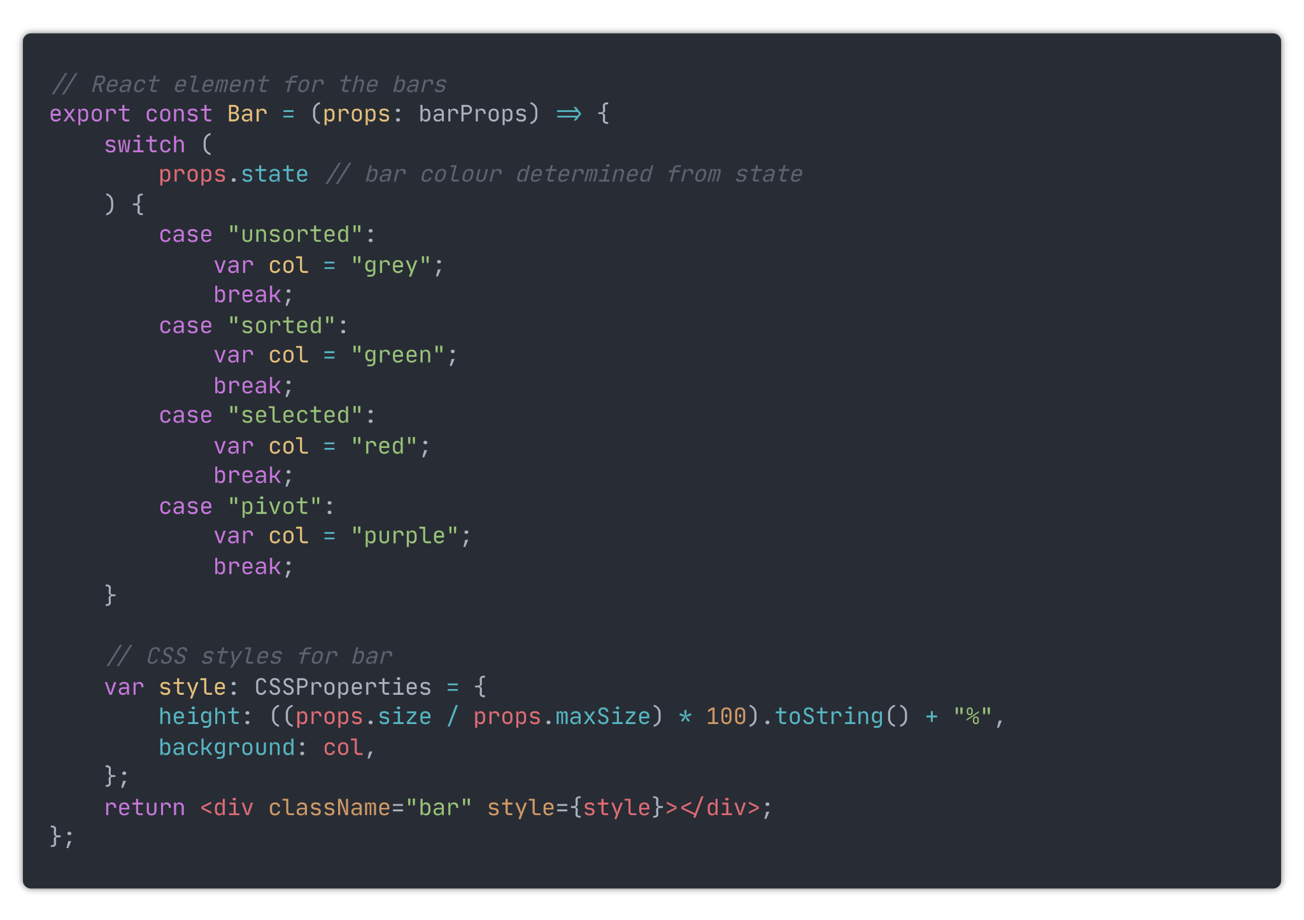

I then modified the `makeBars` method inside the App component so they when the bars are created, they are all set to unsorted. And I changed the `barContainer` component so that the bar's state is passed in as a prop.

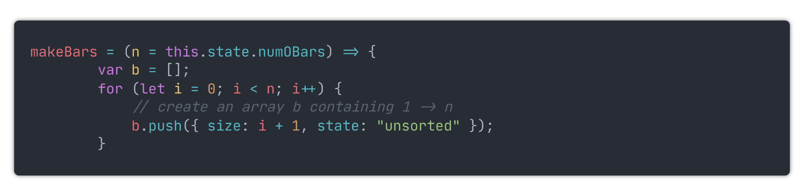

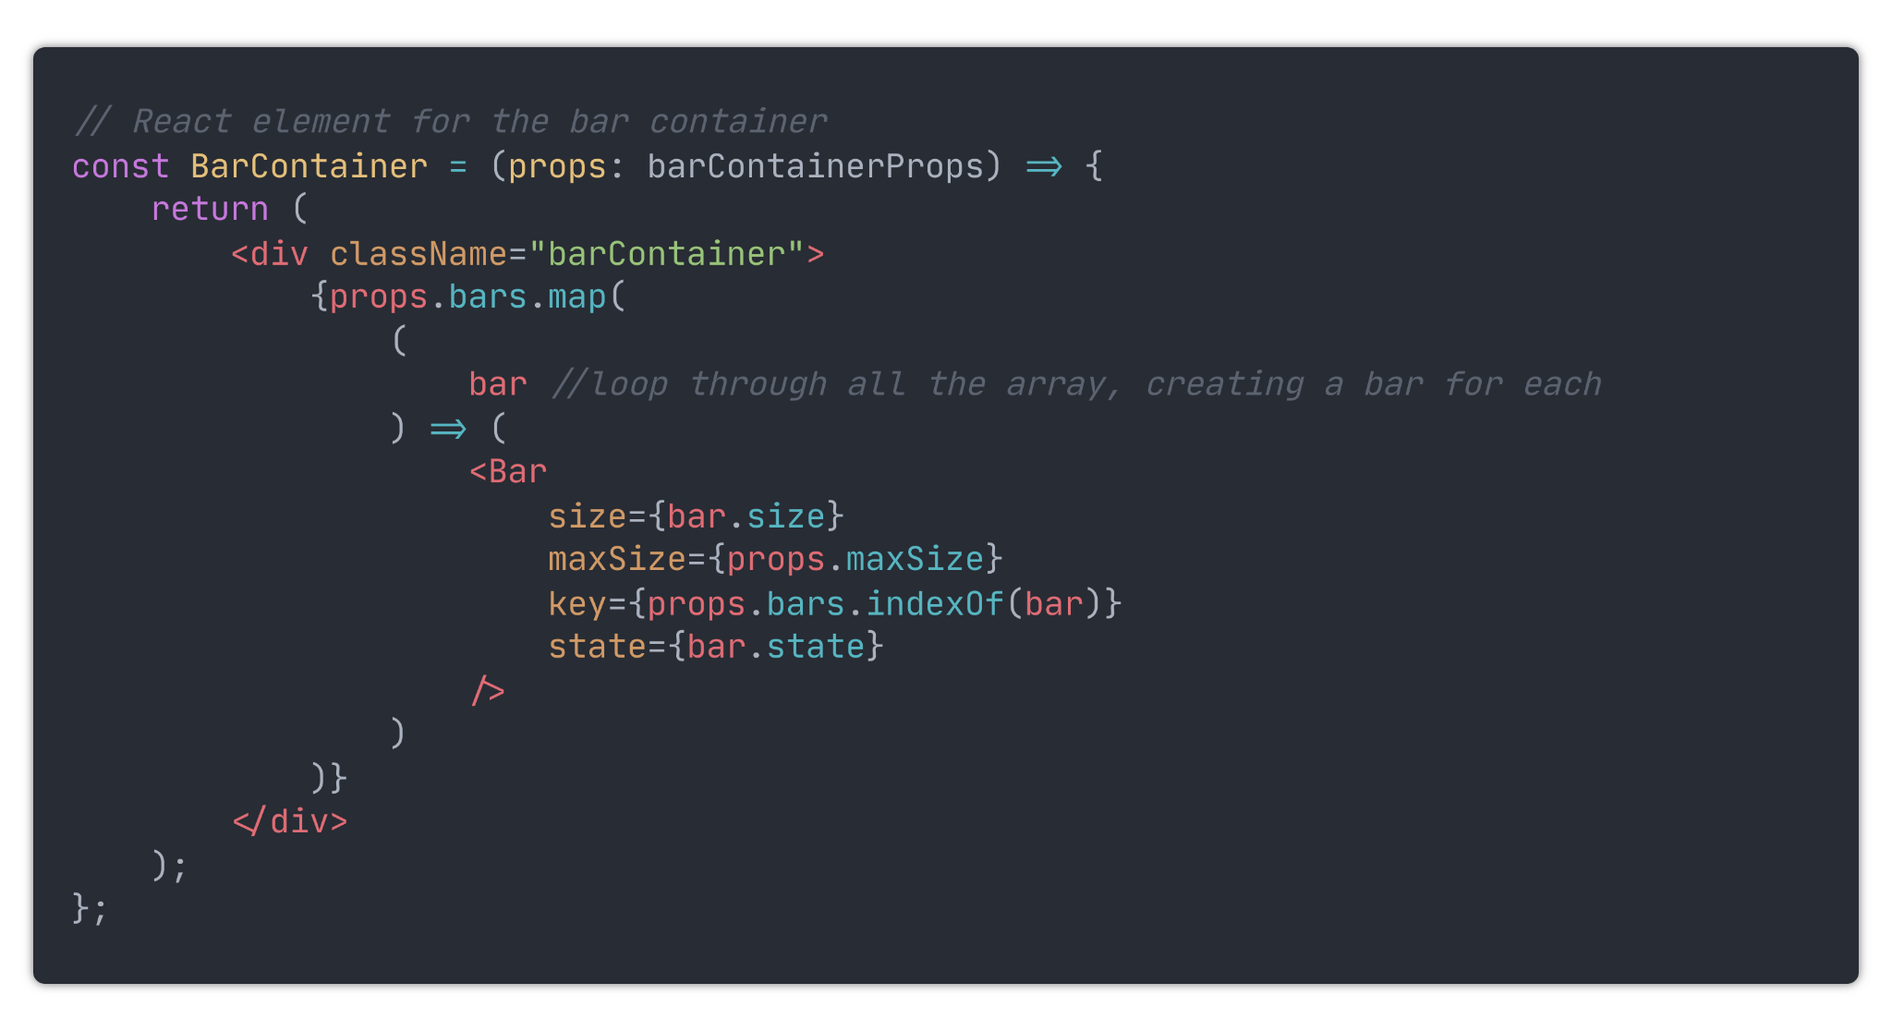

Now that the visualiser can display the different states of the bars, the next step was to modify the bubble sort function so that the states are updated. So that the states can be displayed more accurately, the sorting steps will have to be updated more frequently. This will result in the visualiser being slower on average due to there being more steps. However, this reduced speed is essential for showing the algorithm in more detail.

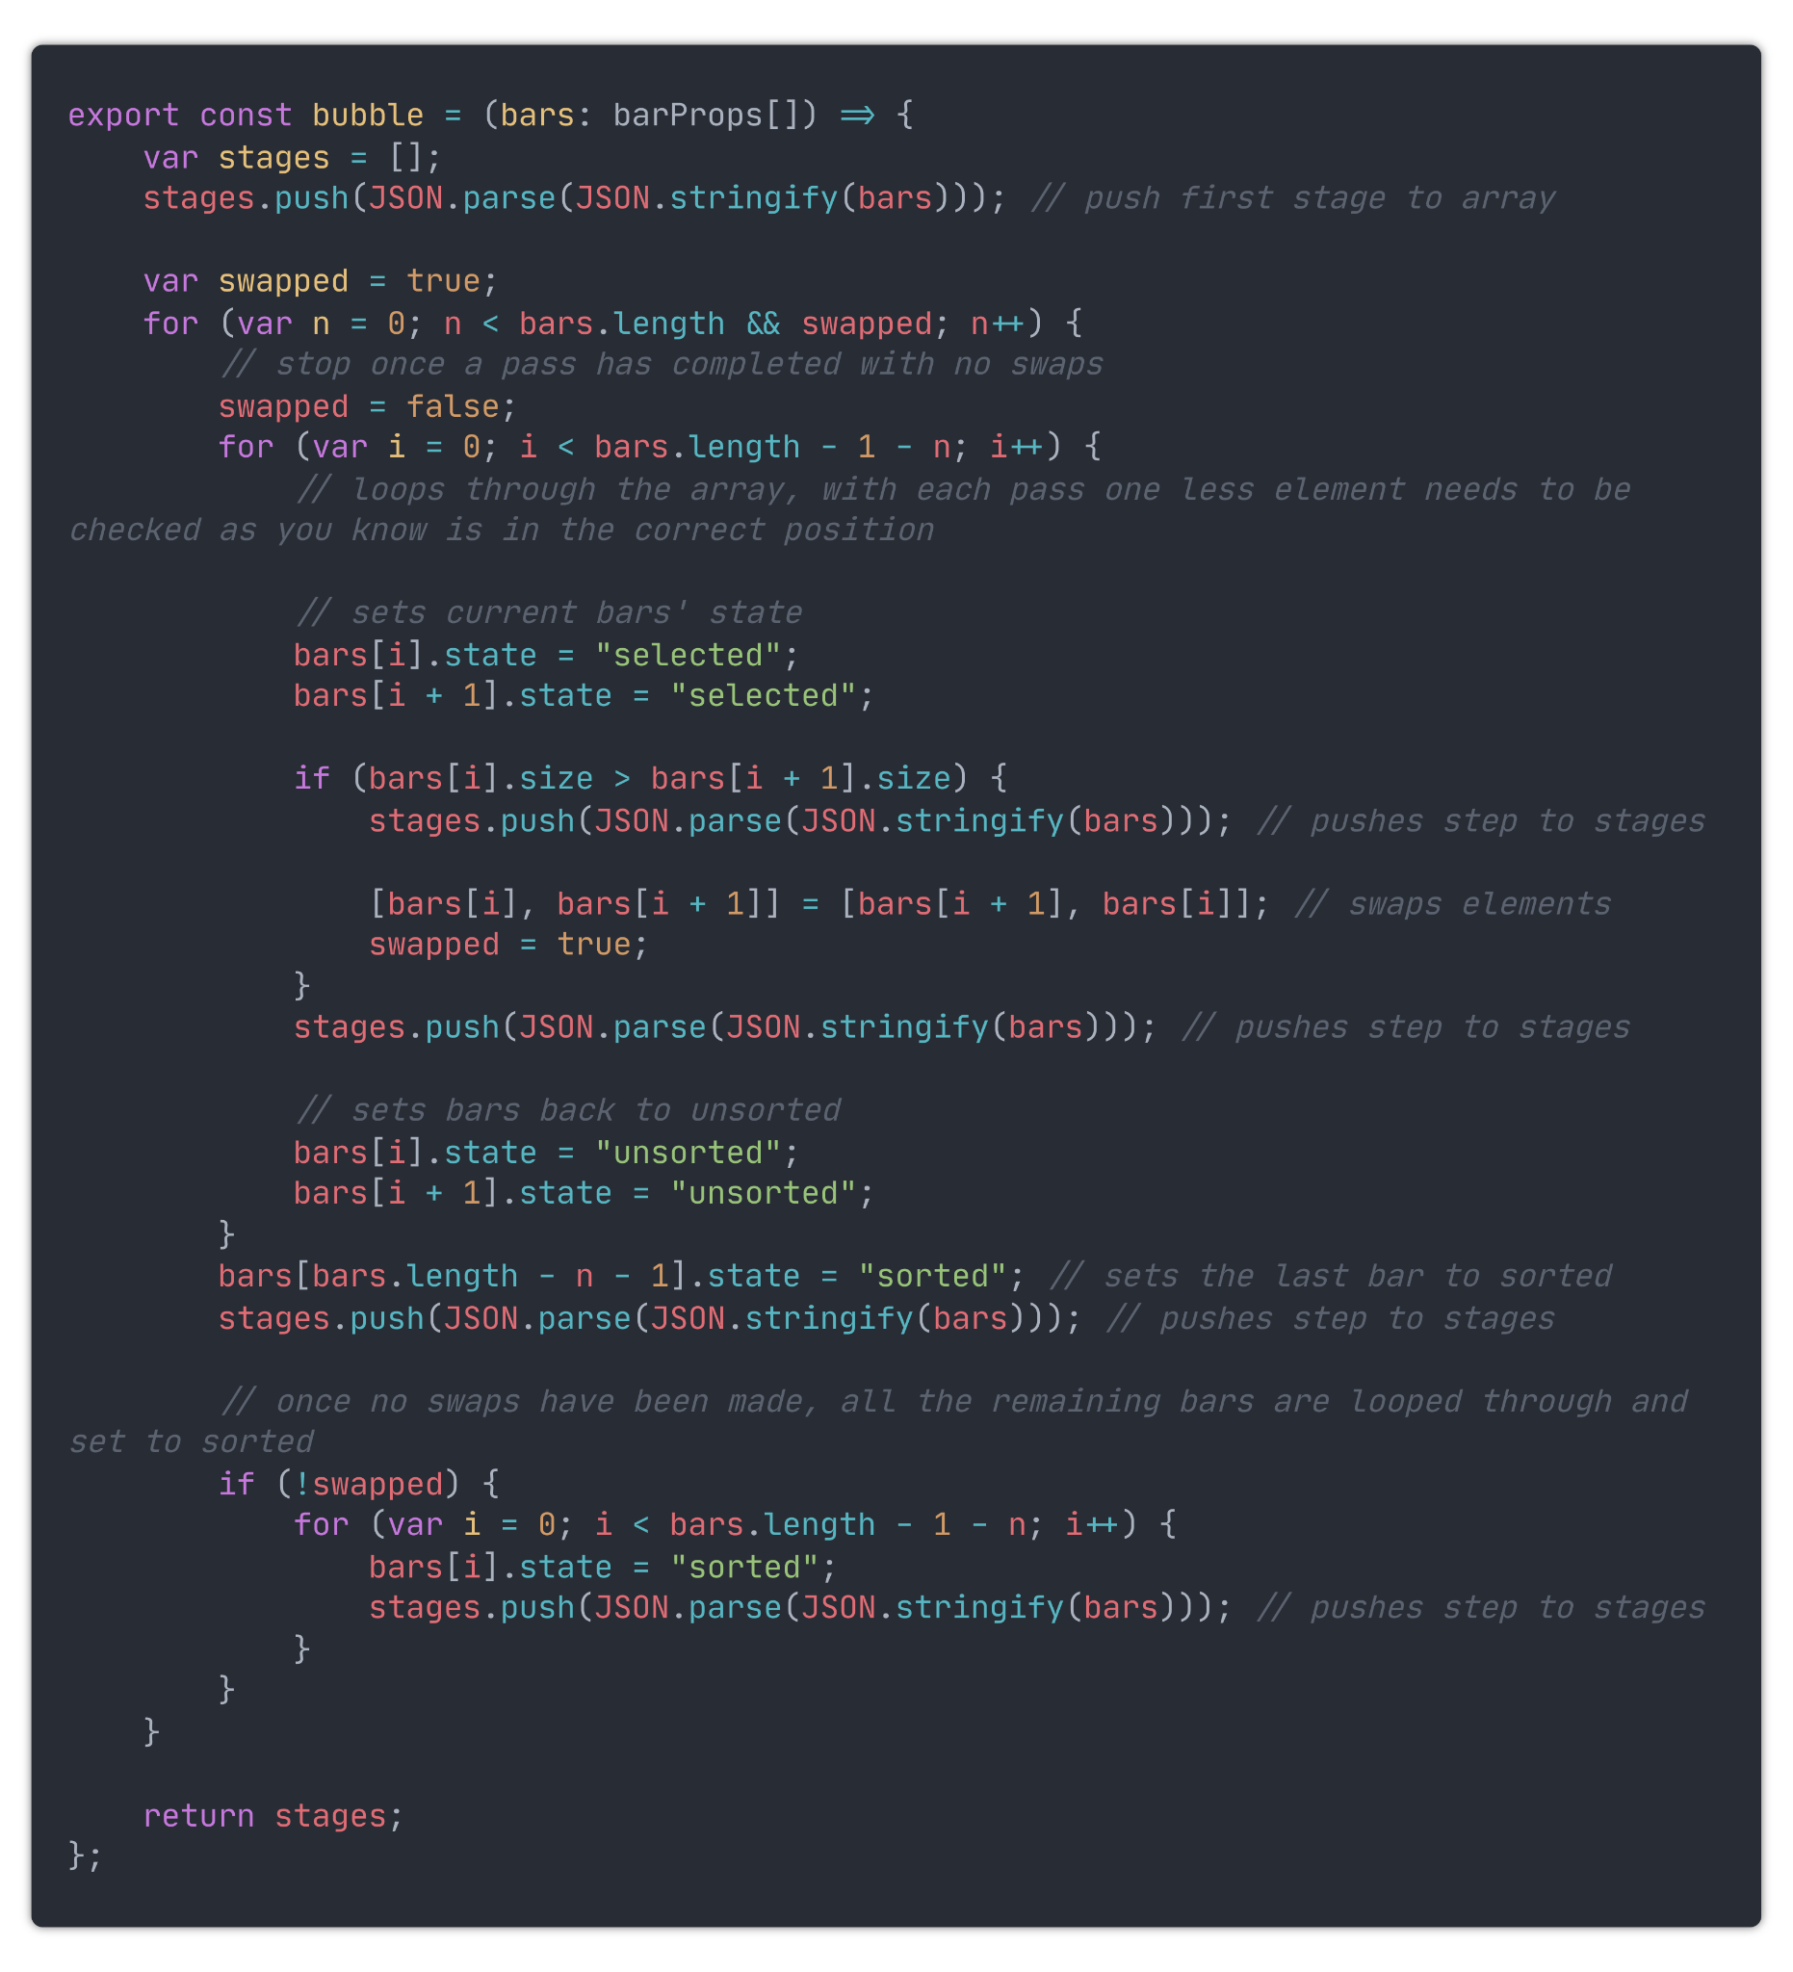

Now, the visualiser can display a visualisation of the selected algorithm with the colouring of the bars. Here is an example of the bars mid-sort:

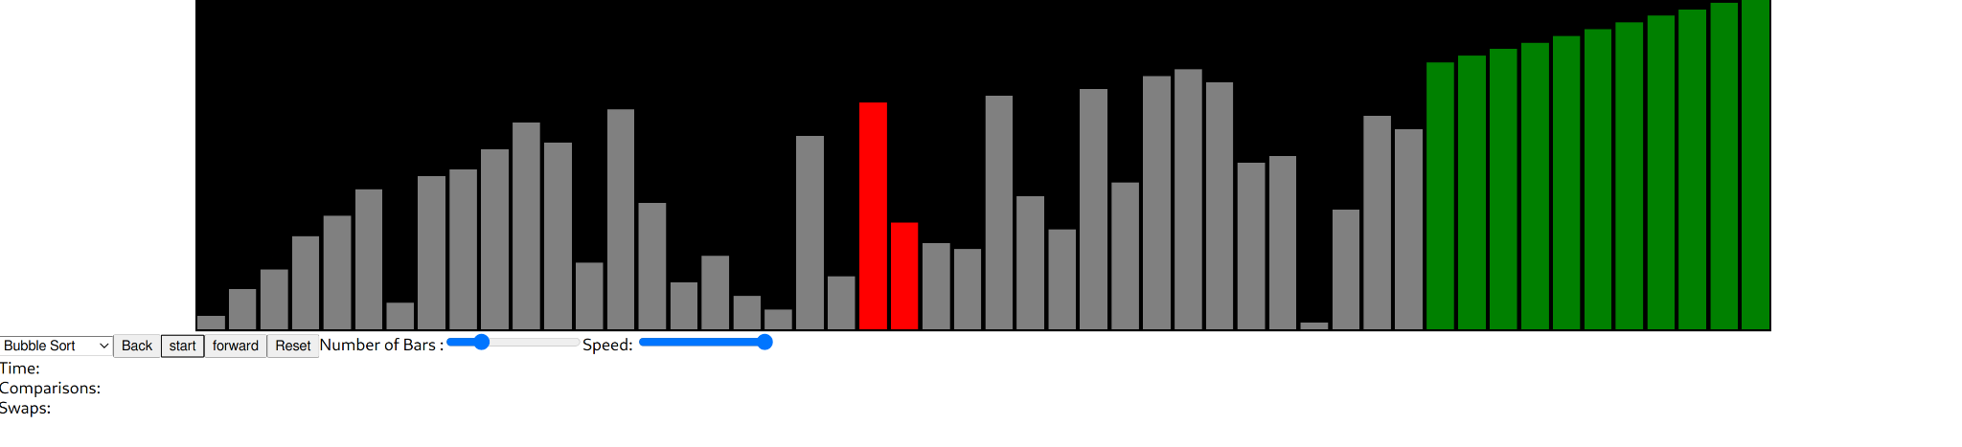

### Swaps and comparisons

Originally I intended to record and display the number of swaps, comparisons, and time taken whist the algorithms are running. However, showing the time will no longer work due to the added ability to step forwards and backwards. Different devices would run at different speeds anyway, so the time would not be consistent. Therefore, I will only display the number of swaps and comparisons made.

First, I modified `algorithms.ts` to record the number of comparisons and swaps taken. Then instead of only the stages of the bars, it now saves the swaps and comparisons too.

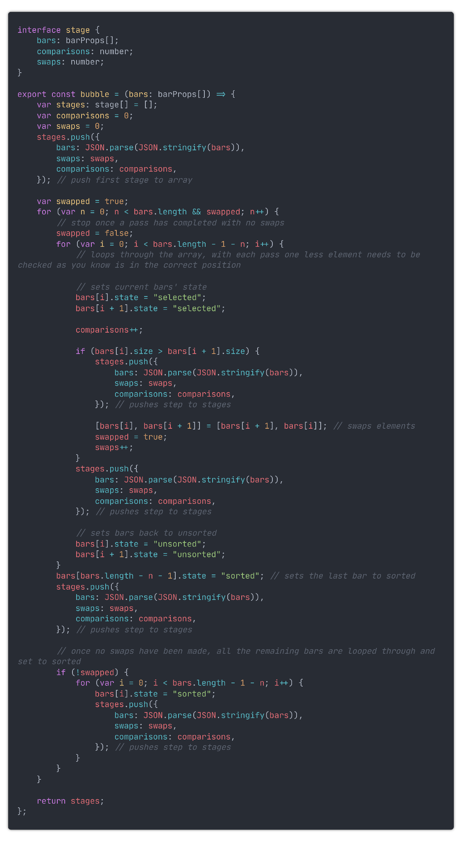

SortingStages is now an array of interfaces containing the bars, swaps, and comparisons for each stage. The code for stepping through the stages needs to be modified to take all the stage parts and add them to the application state. Here is an example of the revised code from the `visualise` method:

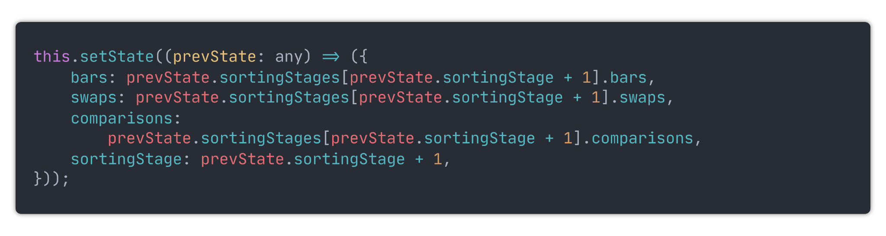

Using those new state values, I then passed them into the `Metrics` component to display them and removed the speed indicator.

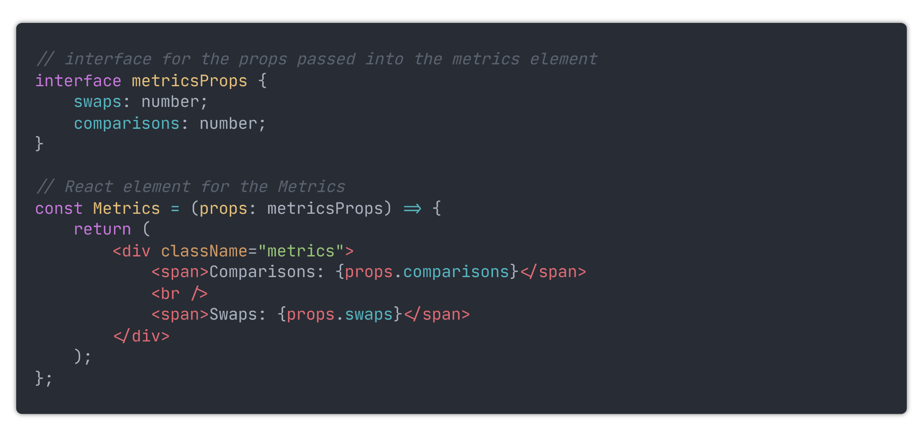

Now, the number of swaps and comparisons carried out are shown under the visualiser.

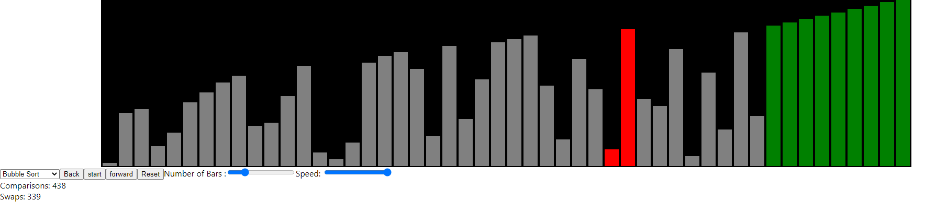

### Type cleanup

So far, I have placed any types and interfaces above where they are needed. This worked fine; however, once these types started to be needed across multiple files, it has become challenging to manage. Therefore I have placed all these types and interfaces inside a new file named `types.ts`.

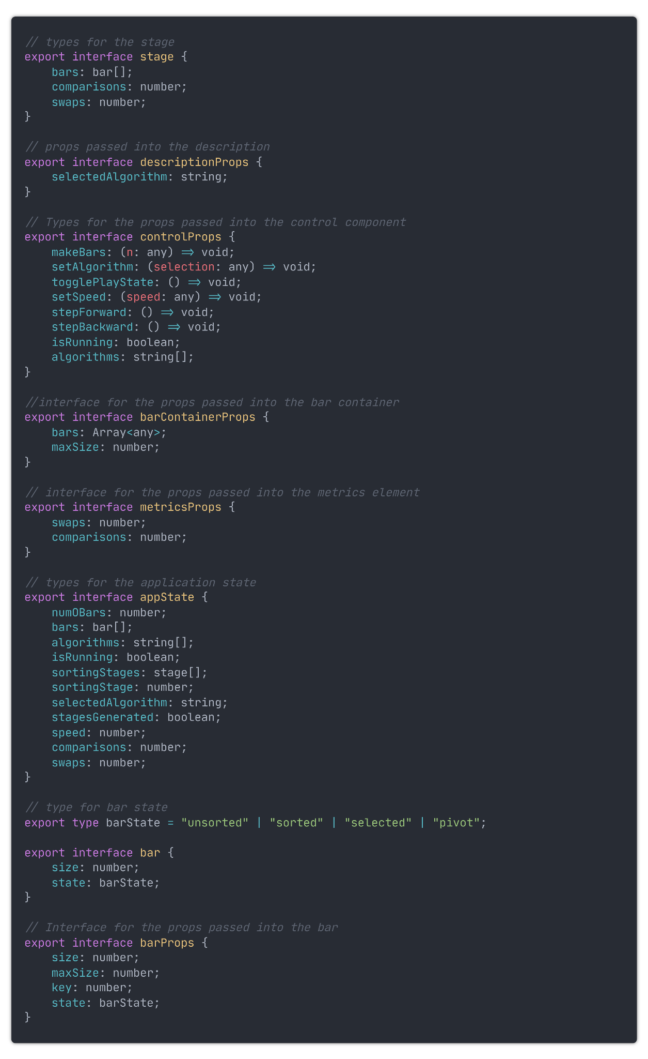

Now, whenever I want to use a type or interface, I can import it at the top of the file.

### Algorithm Description

Next, I need to add the description of the selected algorithm. This description will only be shown when an algorithm is selected.

I started by creating a new file named `description.tsx` where I placed this code.

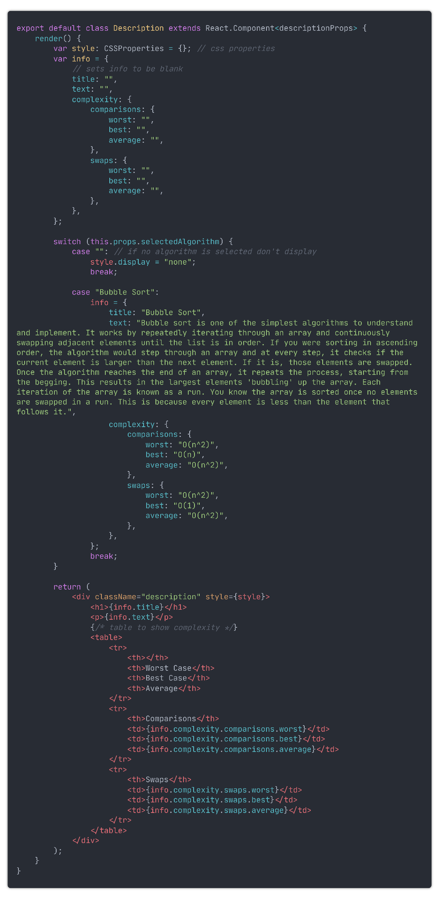

As I am still undecided on the website's visual design, I have left the styling of the description. Once I have decided on how I want the website to look, I will style it. I have also only put in the description for bubble sort as it is the only one I have implemented so far.

Now, the visualiser looks like this:

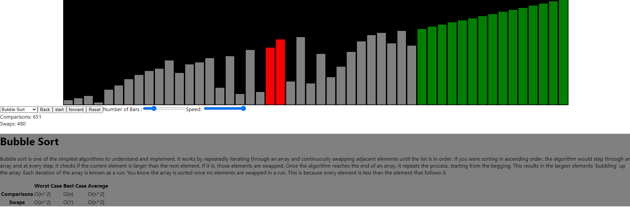

### Progress bar

Alongside the step forward and backwards buttons, I have also decided to add a progress bar for displaying the progress of the visualisation. This will be done using two divs, one outer and one inner. The height of the inner one will be set to 100% of the outer one, and its width will be set to (Current Step/Number of steps) x 100 % of the outer one. here is the code:

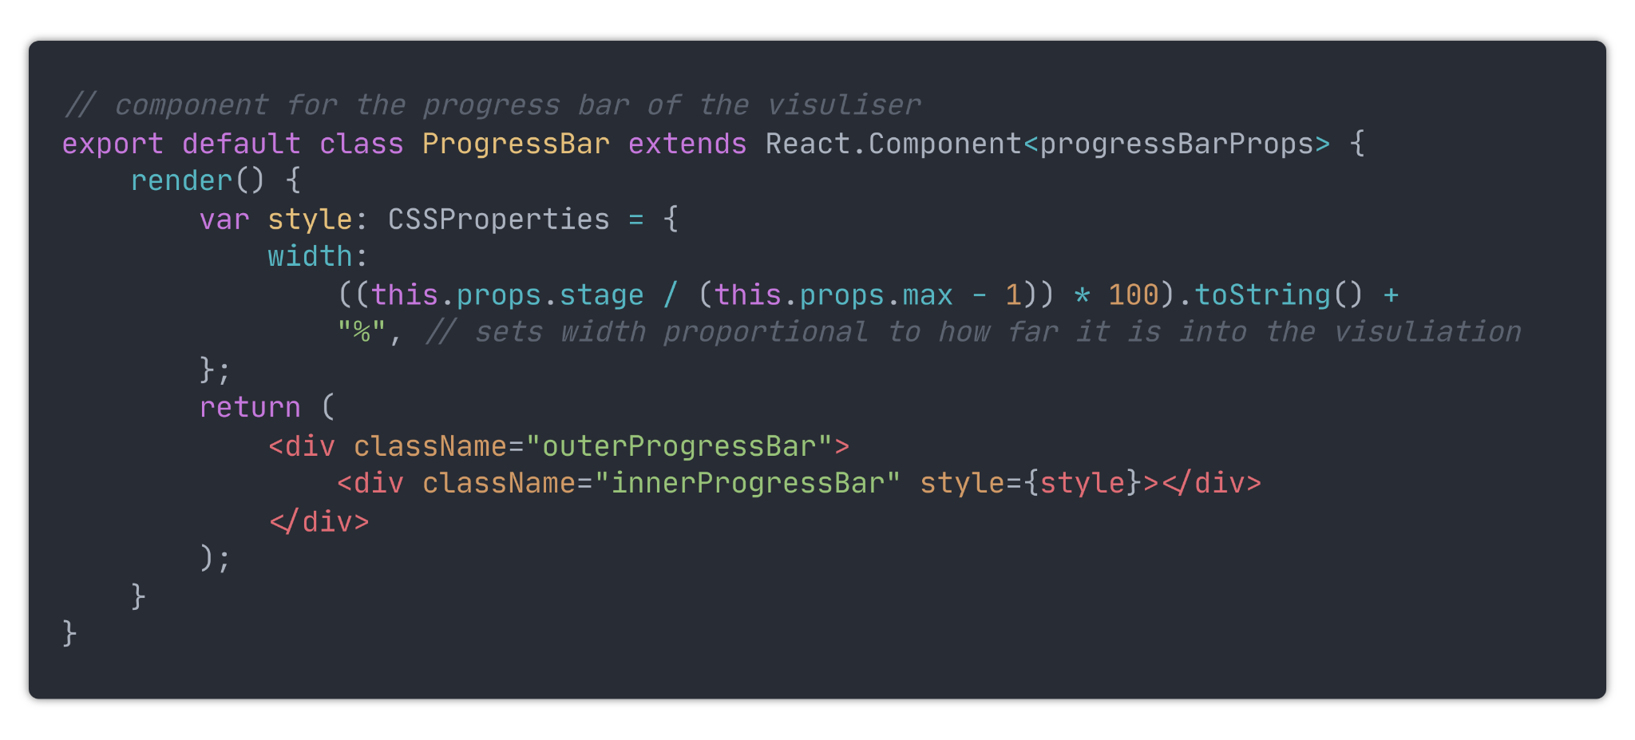

and this is the subsequent CSS

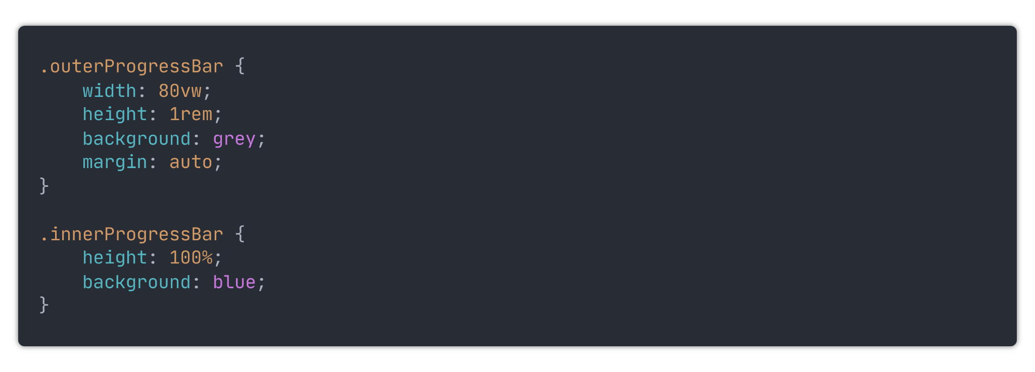

Here is how the visualiser now looks:

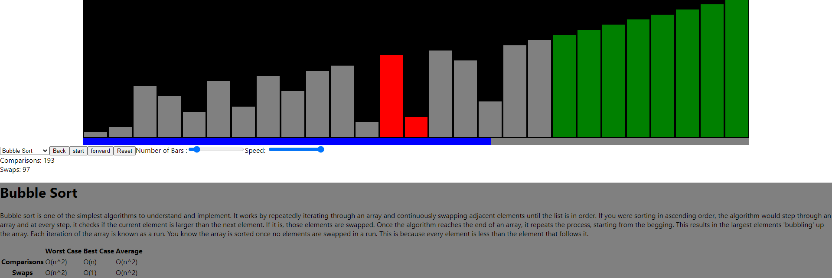

### Component clean-up

I was unhappy with how large the `Controls` component had become. Therefore, I reduced it down to many smaller components. This will allow easier code maintenance and more freedom as to how I arrange them on the screen. It will also make it easier to reuse any of them for the other two visualisers. I created the new files: `algorithmSelector.tsx`, `backButton.tsx`, `startStopButton.tsx`, `forwardButon.tsx`, `resetButton.tsx`, `numOBarsSelector.tsx`, and `speedSelector.tsx`. Which contain respectively:

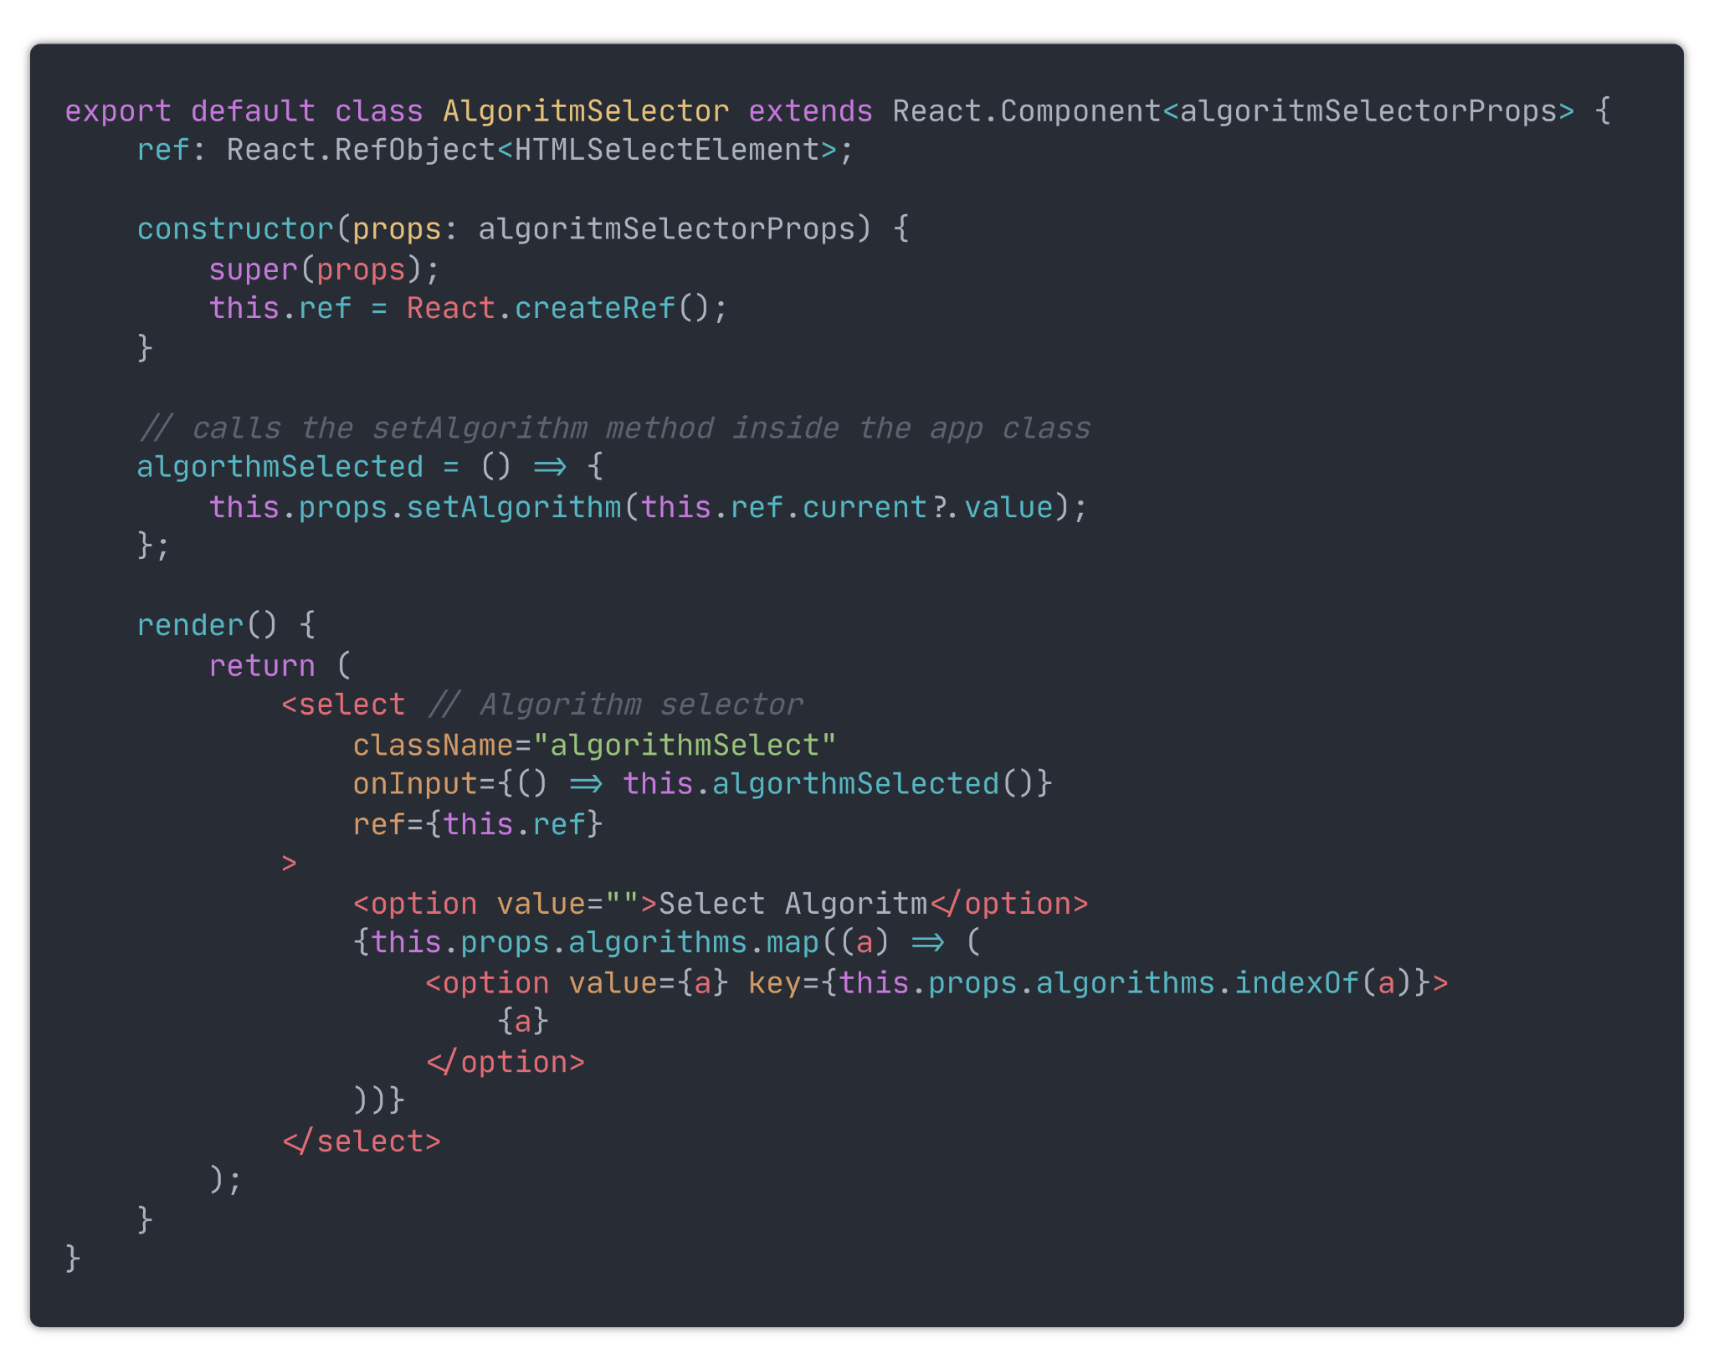

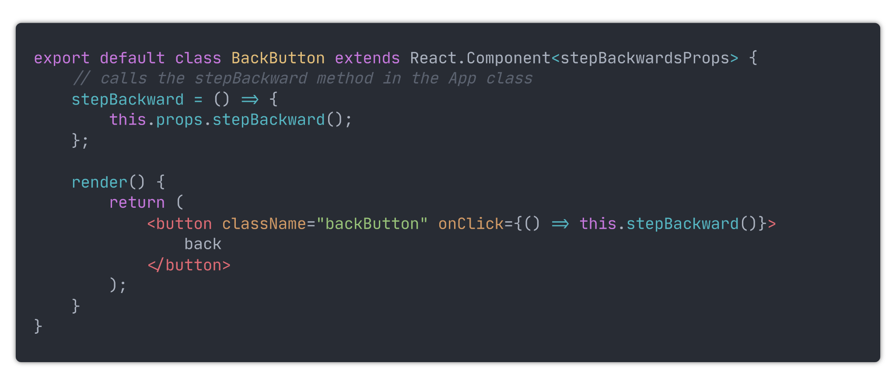

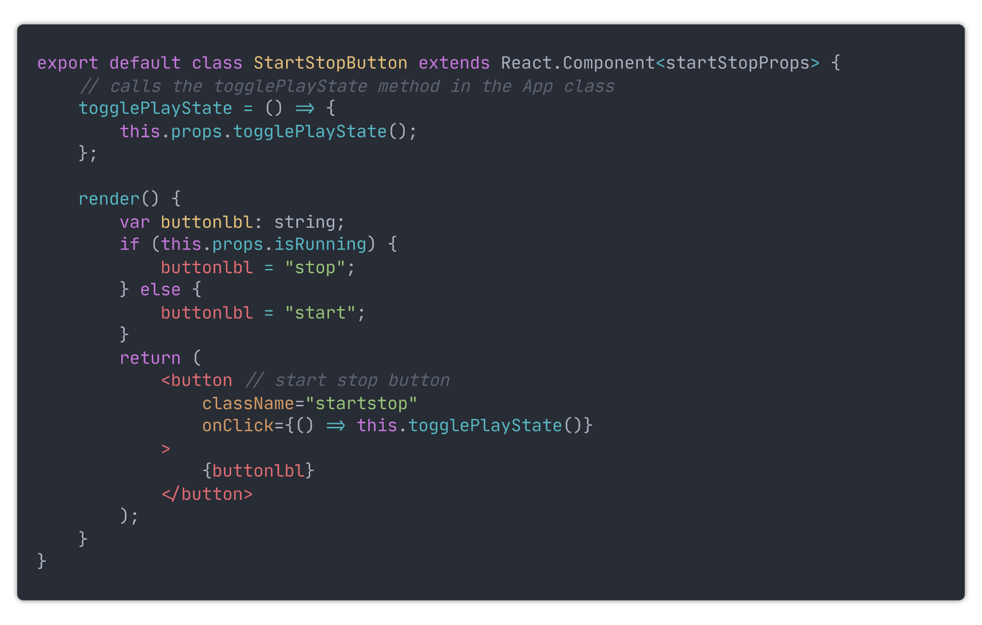

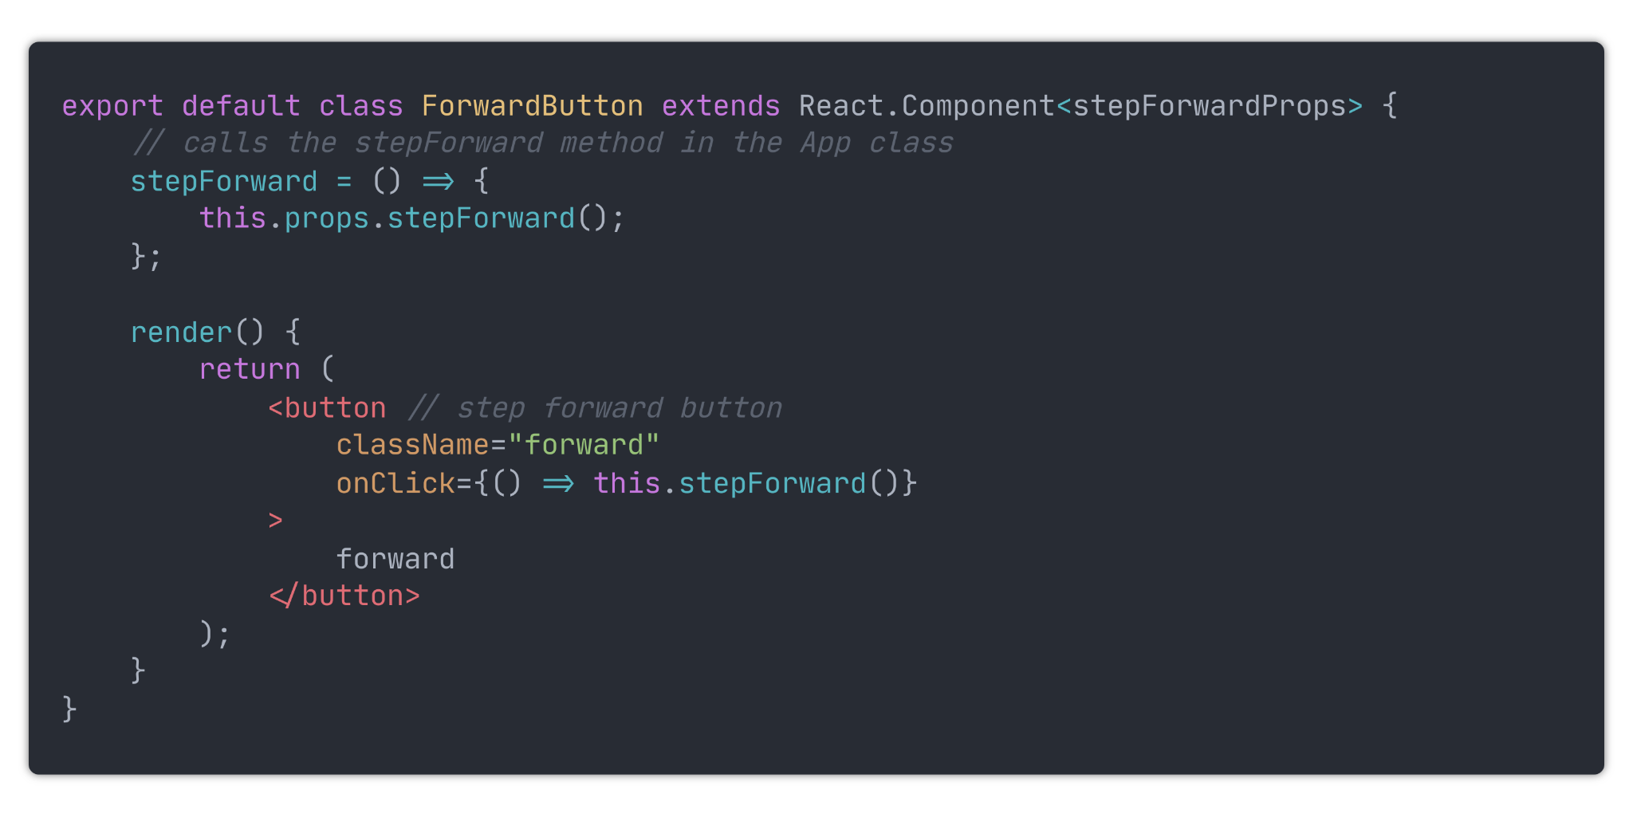

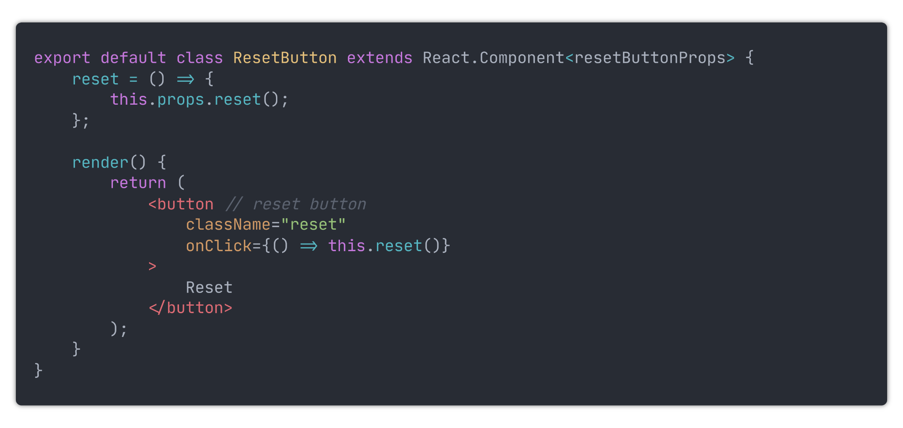

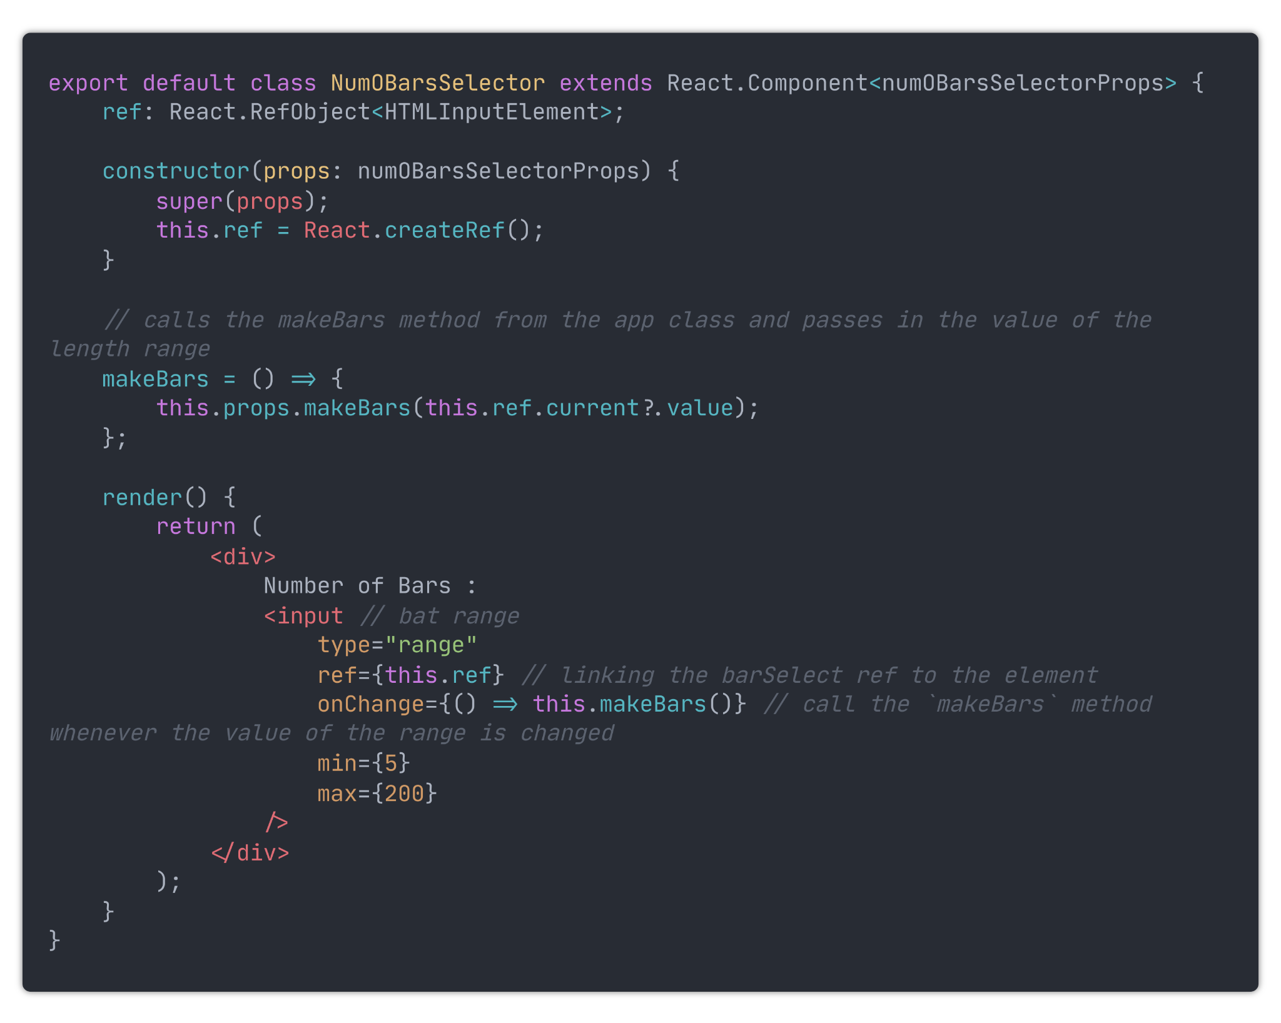

I then moved the `BarContainer` and `Metrics` components into their own files. After that, I re-named the `App` component and file to be `Sorting`. I then made some blank components for the home, searching and pathfinding pages. All of the files containing components were then moved into a new file named `components`. This is now what the folder structure of my src folder is like:

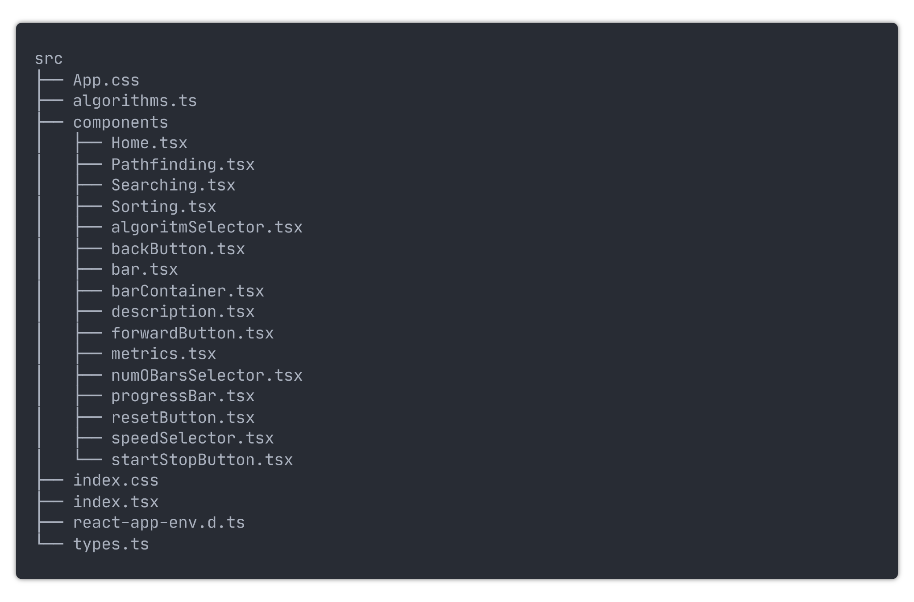

### Colour scheme

Now that all the parts of the sorting visualiser have been created, it is time for visual styling. For the colour scheme, I have decided to use the Nord colour pallet which can be found at https://www.nordtheme.com/. Therefore, to start with, I need to define the colours. I created a file named `colours.css` which contains:

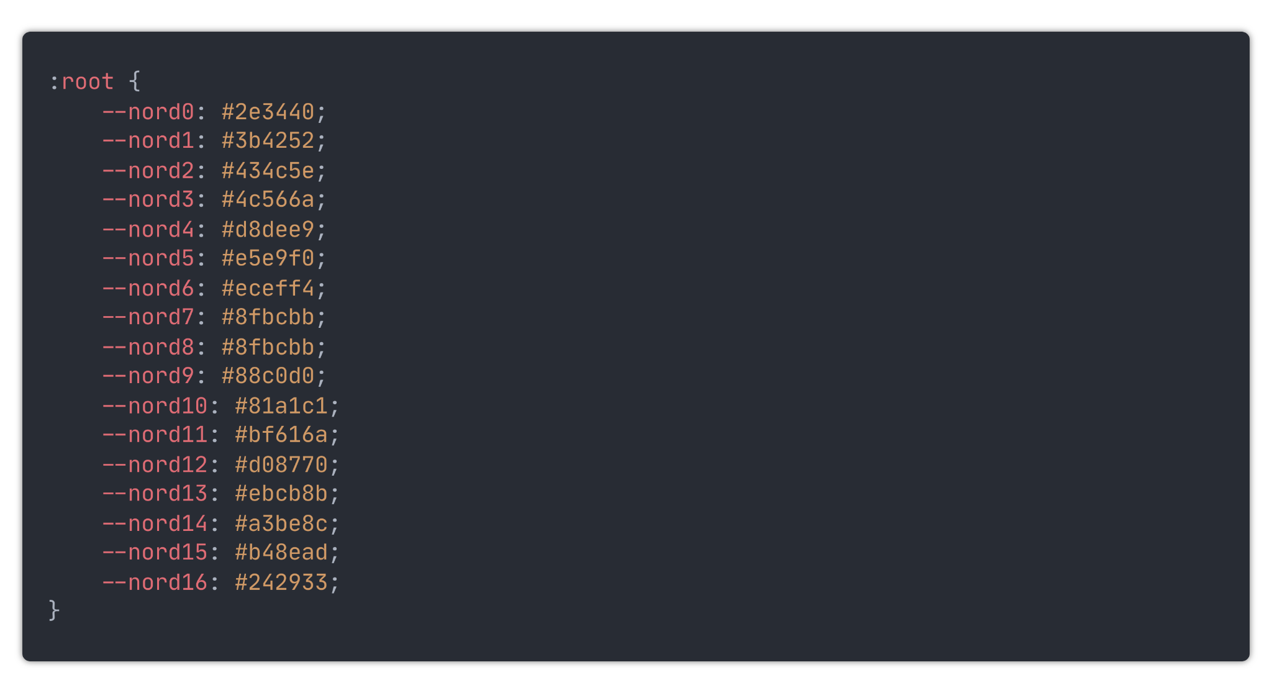

These colours can now be imported into any other CSS file in the project.

### Using the colour scheme

Using the colours set out inside the `colours.css` file, I went out and applied css styling to the application. Instead of having all the CSS styling stored centrally inside of App.css, I further broke down the application into smaller modules, each with their own css file. This can be seen in this file tree.

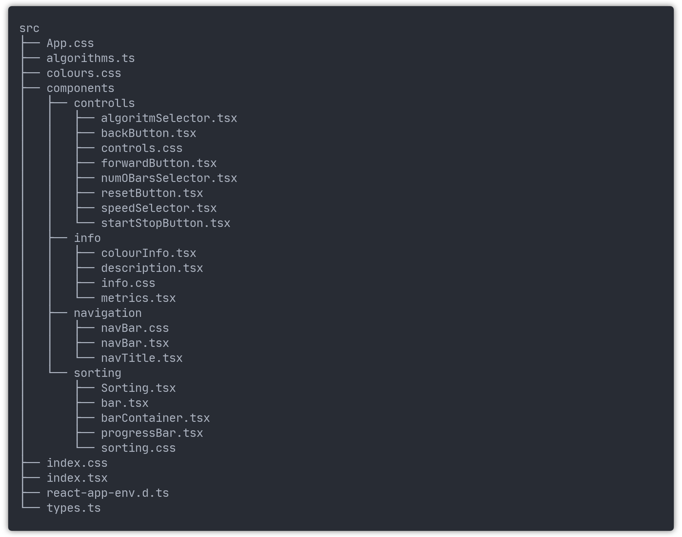

Inside these new CSS files, I then placed the relevant CSS for their respective modules. These files are too long to place inside this document, however they can be found in the application source code. With all the added CSS styling, the application now looks like this:

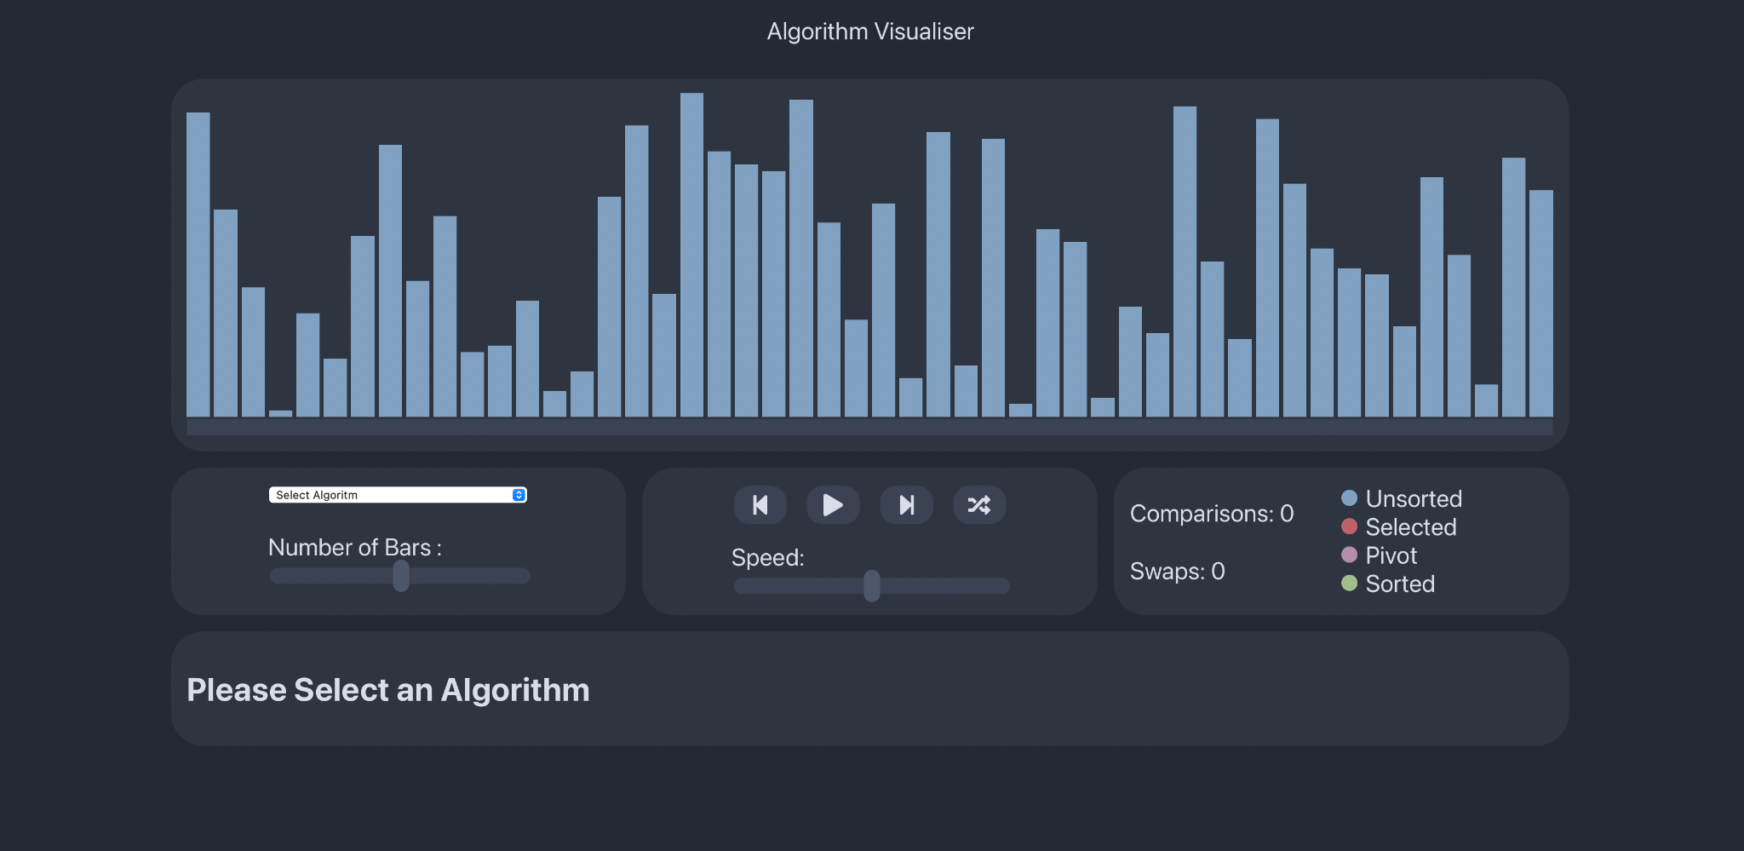

### Implementation of the other algorithms

Thus far, the application has only been able to visualise Bubble sort. I will now implement the other sorting algorithms detailed in the algorithm research section.

#### Quicksort:

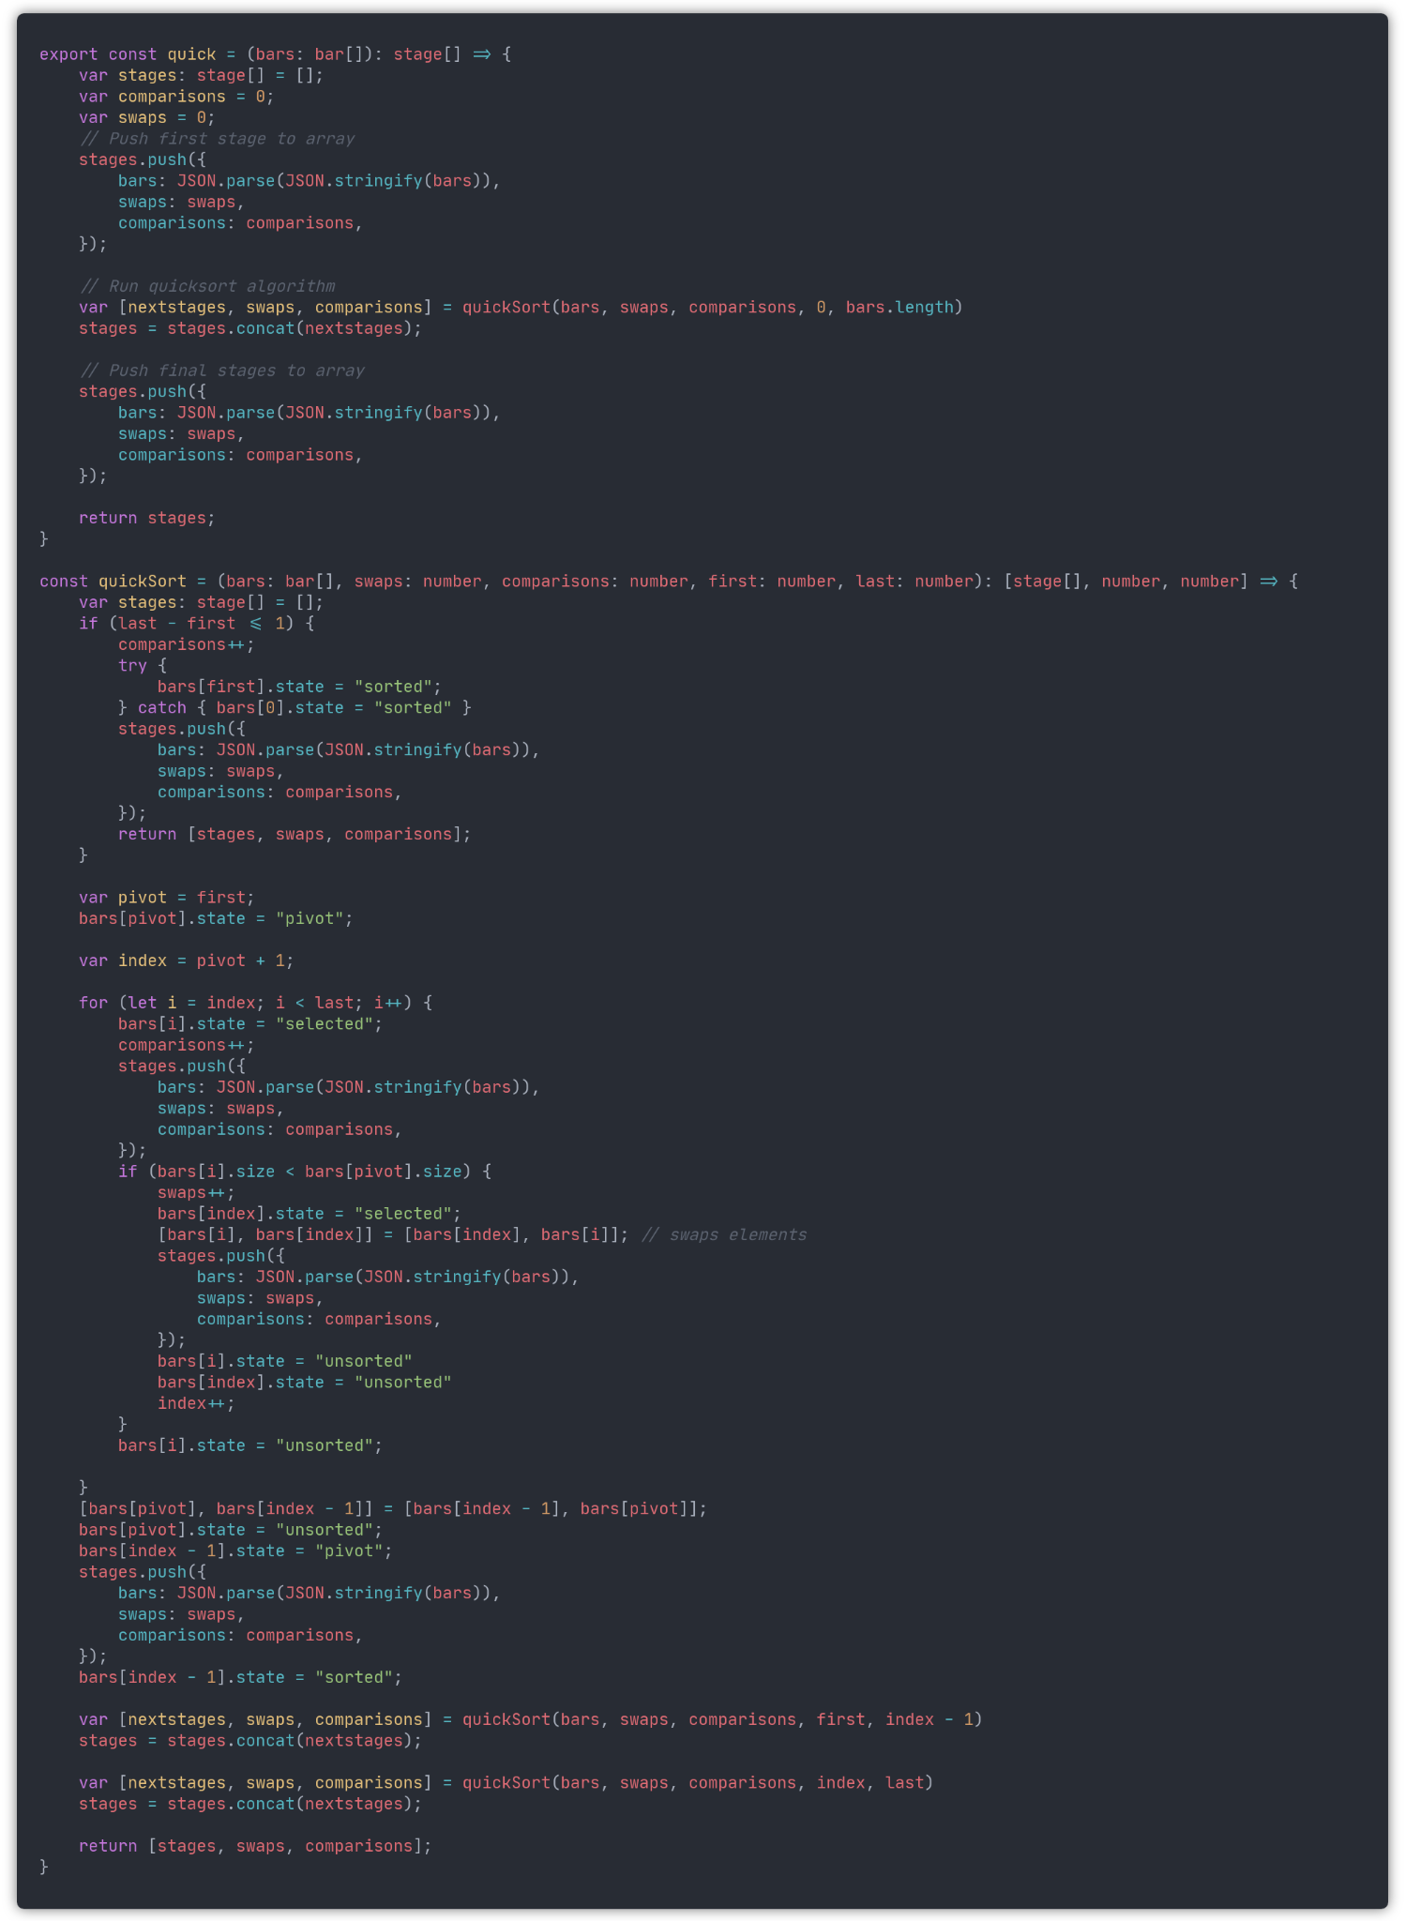

#### Insertion sort

#### Merge Sort

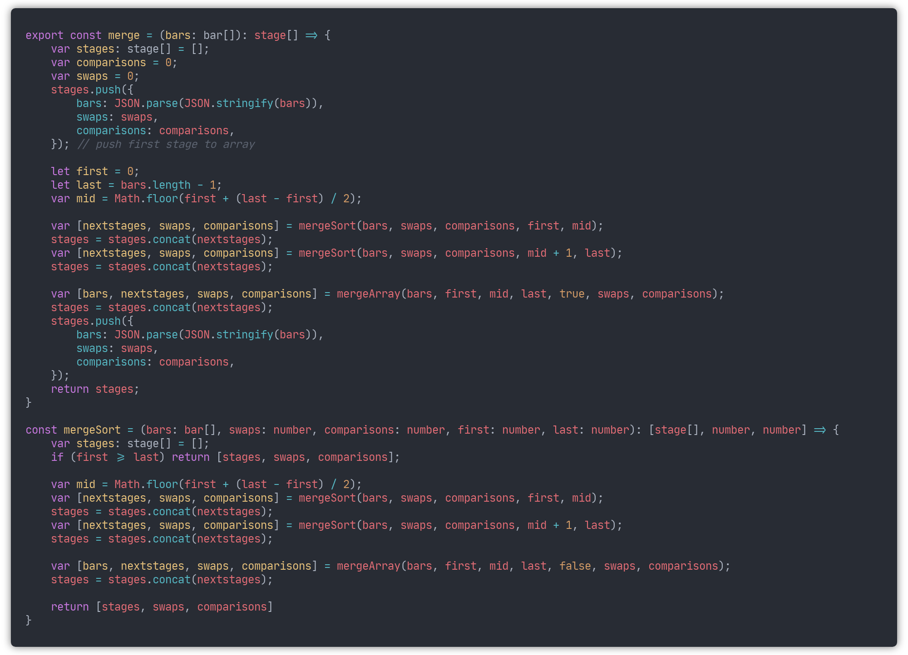

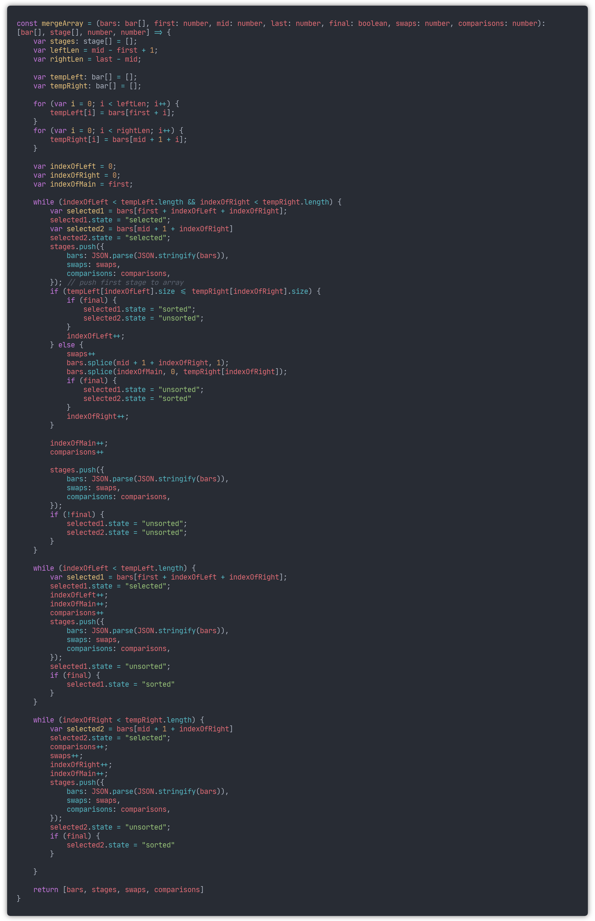

#### 

#### Selection Sort

Now that the sorts have been implemented, the final thing to do is add their descriptions inside descriptions.tsx, and adding calling the sorting algorithms to the runAlgorithm method

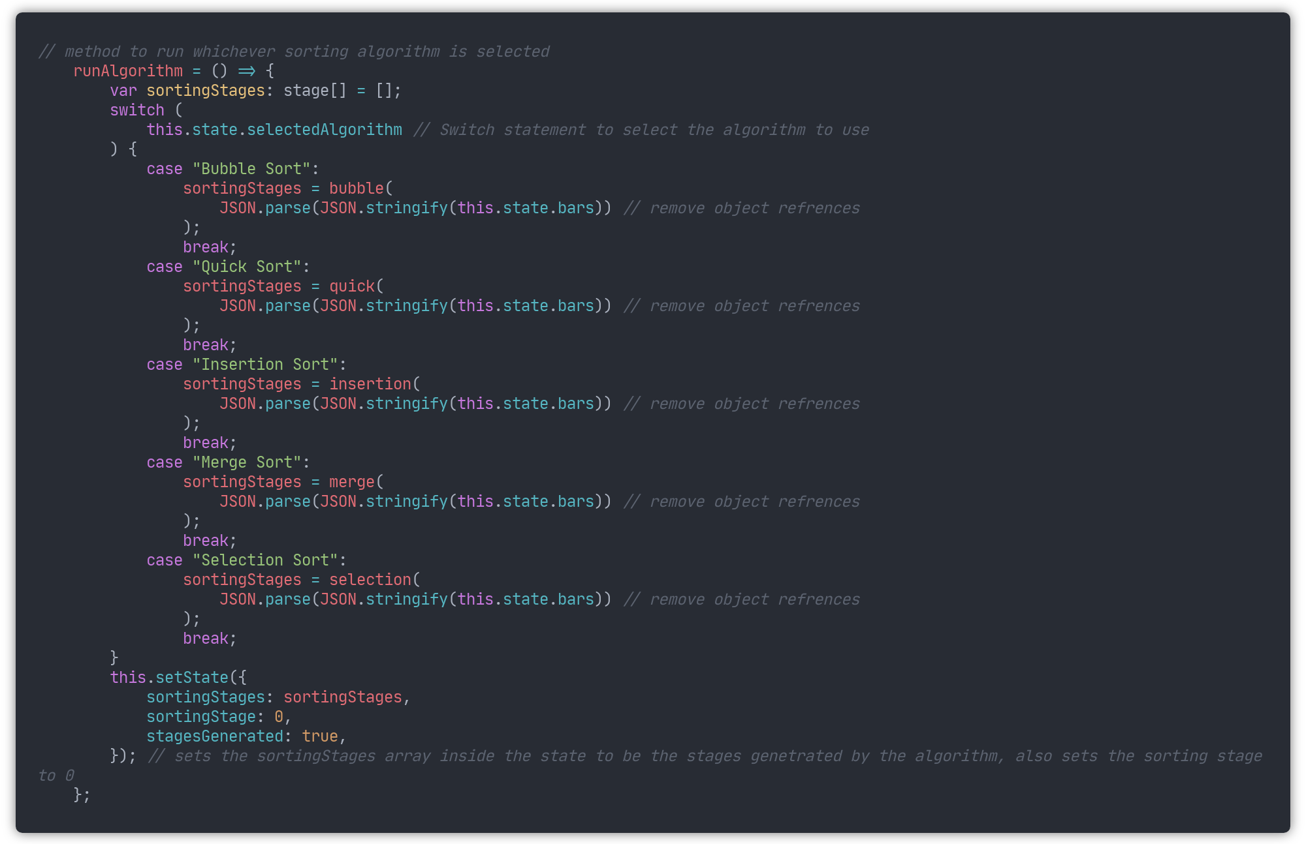

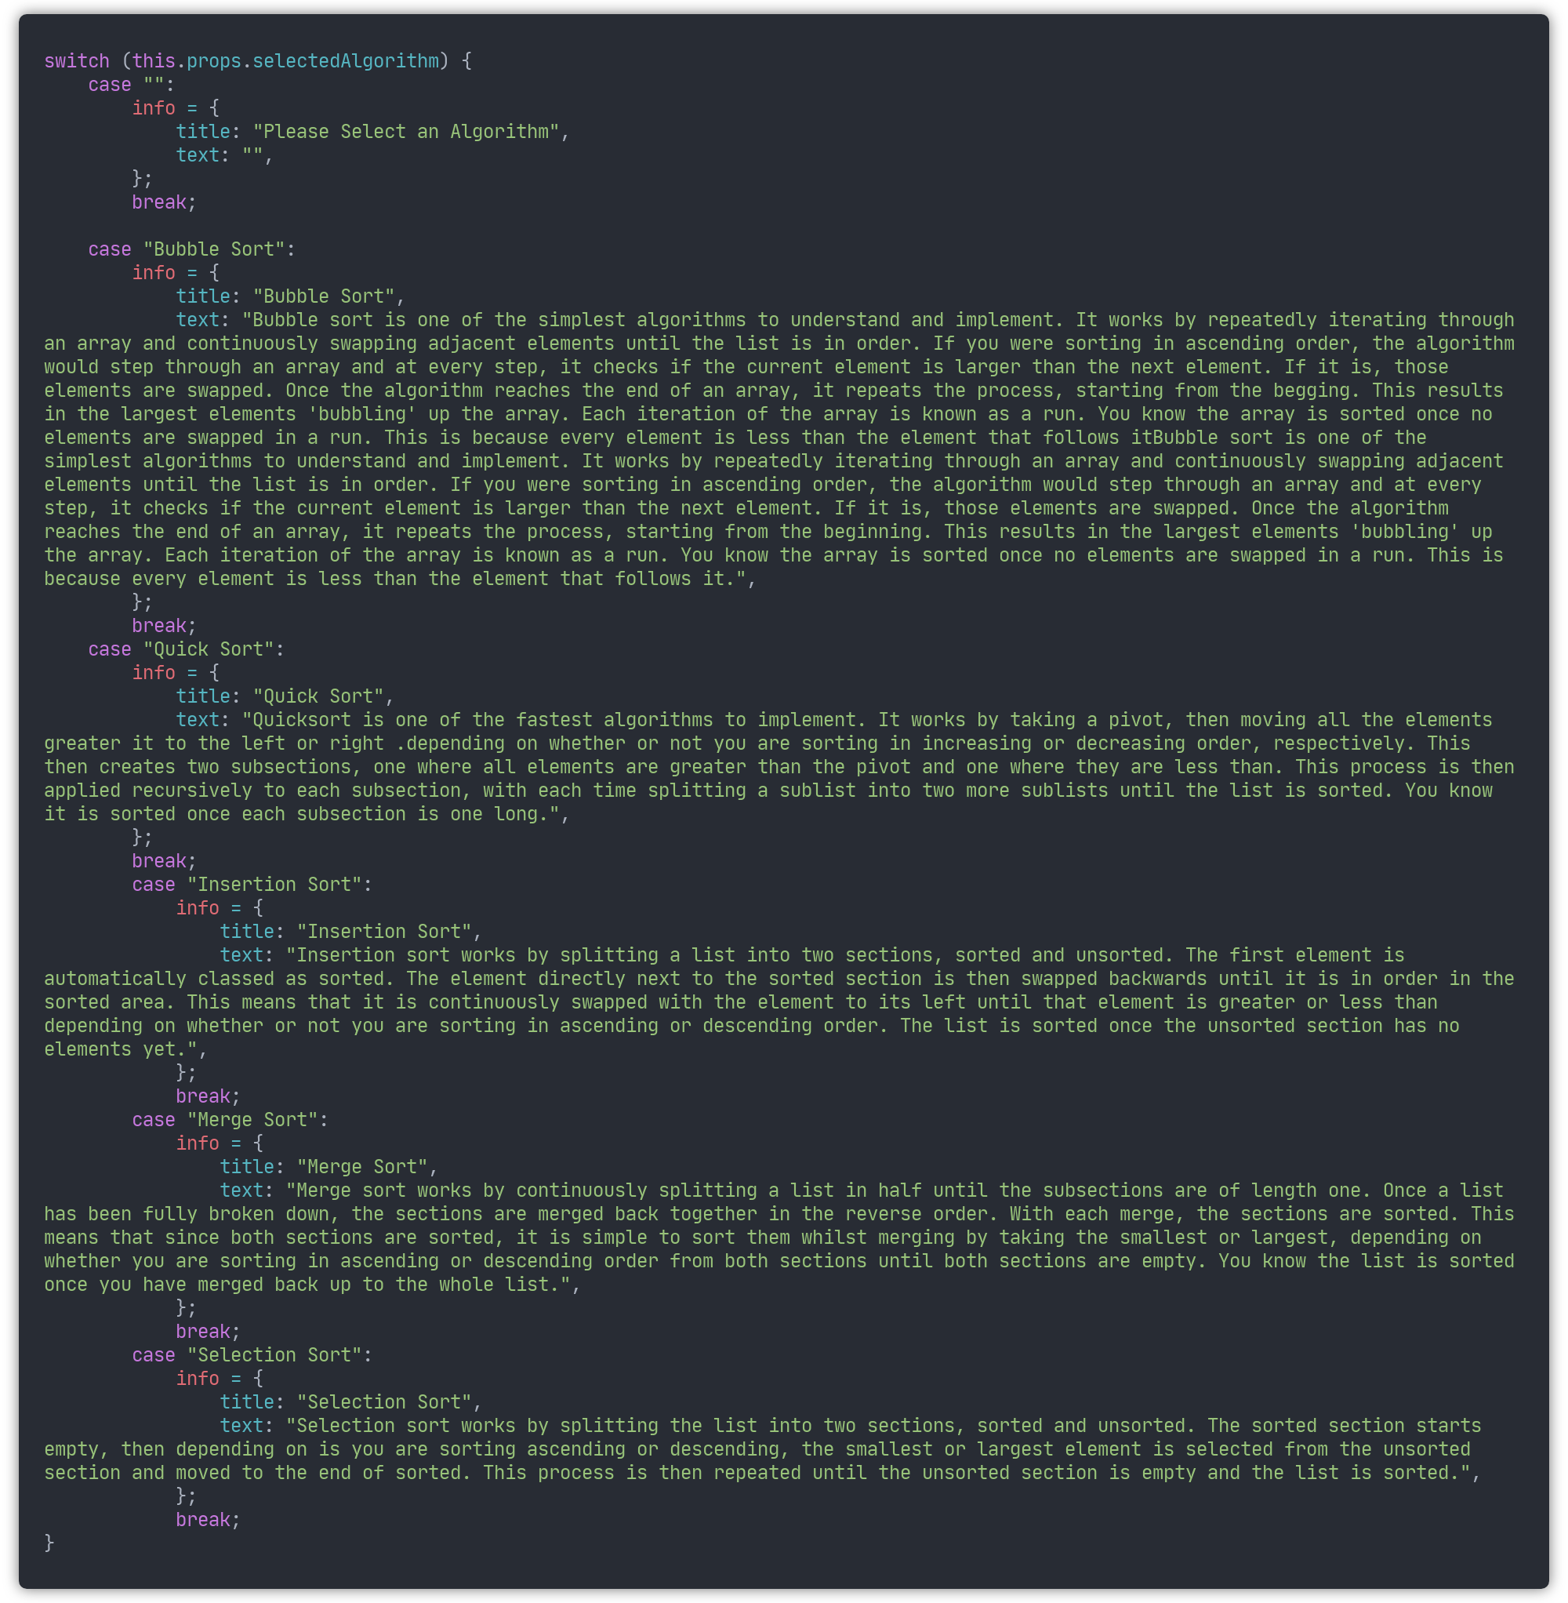

Now you can select any of the algorithms and visualise them. If you change the selected algorithm, the stages reset to the beginning, allowing you to use the same data multiple times and compare the efficiency of the different algorithms. The final application now looks like this:

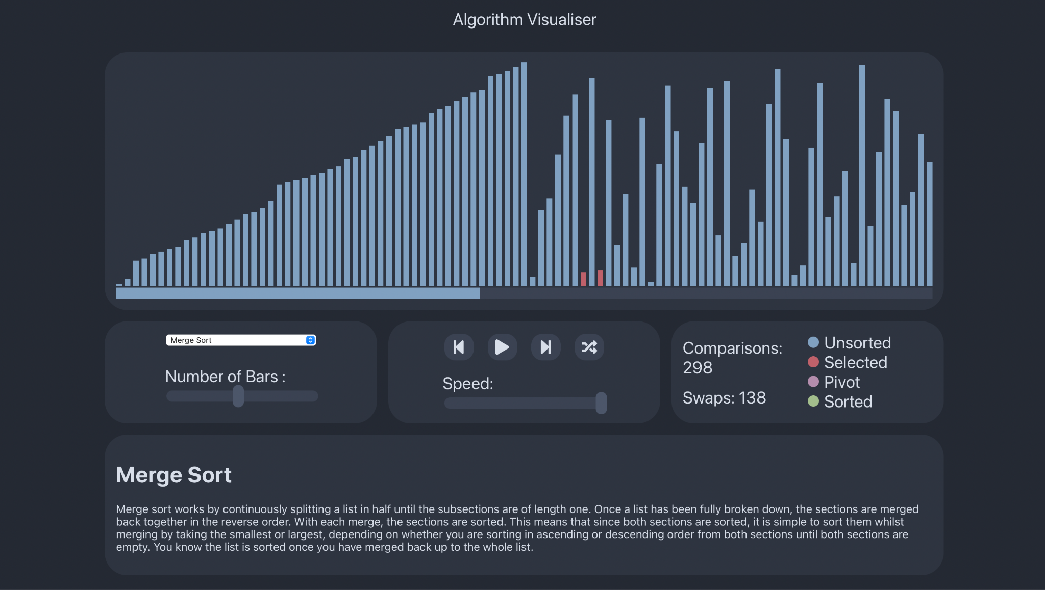

# Conclusion and evaluation

Overall, I think my project has gone very well. I fulfilled the aims set out in my brief, the final application contains visualisations and explanations for five different sorting algorithms, with the ability to adjust the number of items to sort, the speed of the visualisation, and the ability to play, pause, step back, and step forward through the visualisation. The program also counts how many swaps or comparisons are made by the algorithm, allowing for a simple way to compare their effectiveness.

I now have a much-improved knowledge of different sorting algorithms outside the ones I had already encountered in my Further maths and Computer science studies. This broadening of my knowledge grants me a more diverse toolkit when trying to solve programming problems in the future. I also have a new understanding of how to create web applications using the React framework, something I will use again in the future. An extension to this project would be to include visualisations for other types of algorithms, most likely searching and pathfinding algorithms. Due to the modularity and reusability of react, this extension would be able to use a lot of the same code.

# Bibliography

Bond, K. R., 2017. In: *A Level Computer Science for AQA Unit 1.* s.l.:Educational Computing Services, pp. 241 - 345.

Geeks for Geeks, 2022. *Bubble sort.* [Online]   
Available at: https://www.geeksforgeeks.org/bubble-sort/

Geeks for Geeks, 2022. *Selection Sort.* [Online]   
Available at: https://www.geeksforgeeks.org/selection-sort/

Hoare, C. A. R., 1962. Quicksort. *The Computer Journal,* 5(1), pp. 10-16.

Kahn Academy, n.d. *Insertion sort.* [Online]   
Available at: https://www.khanacademy.org/computing/computer-science/algorithms/insertion-sort/a/insertion-sort

Knuth, D. E., 1989. *The Art of Computer Programming. Volume 3. Sorting and Searching..* 2nd Edition ed. s.l.:s.n.

Meta Platforms, Inc, 2022. *React Homepage.* [Online]   
Available at: https://reactjs.org

Microsoft, 2022. *Typescript handbook.* [Online]   
Available at: https://www.typescriptlang.org/docs/handbook/2/basic-types.html

RisingStack Engineering, 2021. *The History of React.js on a Timeline.* [Online]   
Available at: https://blog.risingstack.com/the-history-of-react-js-on-a-timeline/

Stack Overflow, 2021. *Stack Overflow 2021 Developer Servey.* [Online]   
Available at: https://insights.stackoverflow.com/survey/2021

Watumull, J., Hauser, M., Roberts, I. & Hornstein, N., 2014. On Recursion. *Frontiers in psychology,* Volume 4, p. 1017.